Volume 63 Number 2 2025
NATIONAL
SOCIAL
SCIENCE
PROCEEDINGS
Official Proceedings of the National Social Science Association



Name of Publication: NATIONAL SOCIAL SCIENCE PROCEEDINGS
Issue: Volume 63 Number 2, 2025

Office of Publication: Austin Peay State University
College of Education
Clarksville, TN 37040

Online journals: https://nssascholars.org/publications/

E-mail address: brusterb@apsu.edu

The National Social Science Technology Journal is abstracted in Cabell's Directory, Eric Clearinghouse, EBSCO, Economic Abstracts, Historical Abstracts, Index to Periodical Articles, Social Science Source, Social Science Index, Sociological Abstracts, and the University Reference System.

We wish to thank all authors for licensing the articles. We would like to thank all those who reviewed these articles for their publication.

This work is licensed under a Creative Commons Attribution 3.0 License.

Editor: Benita G. Bruster, Austin Peay State University

Junior Editor, Olivia Wild, Austin Peay State University

NATIONAL SOCIAL SCIENCE PROCEEDINGS
Volume 63 # 2
2025
Table of Contents
“Evidence is Mounting that Putting Pen to Paper has Benefits that Typing Cannot Replace”
Barba Aldis Patton, University of Houston-Victoria
Teresa LeSage Clements, University of Houston-Victoria 4

The Power of Play and Flow in the Elementary Classroom
Brooke Carlyann Garza, M.Ed. St. Agnes Academy
Dr. Teresa LeSage Clements UH--Victoria
Dr. Barba Aldis Patton UH—Victoria 8

Analysis of Customer Satisfaction for Target
Beheruz N. Sethna, University of West Georgia
Ujunwa Johnson-Obi, University of West Georgia
Kyrk Walker, University of West Georgia
Evan Angle, University of West Georgia
Ryan Bennett, University of West Georgia
Kennedy Broughton, University of West Georgia
Mariana Ceja, University of West Georgia
Hansol Choi, University of West Georgia
Gisele Libert, University of West Georgia 13

Comparative Analysis of Global Poverty (1990 to 2022)
Prof. M. Prasada Rao, Andhra University, Visakhapatnam, Andhra Pradesh, India, Visiting Faculty,
Dept. of Economics, Central University of Odisha, Koraput, Odisha
Prof. Vani Kotcherlakota, Dept. of Economics, University of Nebraska at Kearney 92

Essential Early Childhood Educator Dispositions: The Love & Care for Children
Dr. Teresa LeSage Clements, UH-Victoria
Dr. Barba Aldis Patton, UH-Victoria
Dr. Lynda Cavazos, UT San Antonio 116

Anomalies make Math Skills difficult for Students
Barba Aldis Patton, University of Houston-Victoria
Teresa LeSage Clements, University of Houston-Victoria 122

Understanding Why In 1888 and In 1892: The Incumbent President Did Not Win The Election
Darrial Reynolds, South Texas College 125

“Evidence is Mounting that Putting Pen to Paper has Benefits that Typing Cannot Replace”

Barba Aldis Patton, University of Houston-Victoria & Teresa LeSage Clements, University of Houston-Victoria

History has shown that handwriting can be dated back as far as 1800 BC. Three major cultures are mainly responsible for the development of writing. Sumerian had cuneiform approximately 3000 BC, Egyptian hieroglyphs around 2800 BC, and the precursor to Kanji Chinese around 1800 BC. Without the development of writing, cultures may not have been able to develop. Writing development allows cultures to record events, history, laws, theories in math, science, medicine, creating literature, and much more. Writing began with simple pictograms representing people, places, and things. This might even be the beginning of grammar as we know it today. More investigation is definitely needed. The pictographs evolved into ideographs, which were abstract symbols that transcended the original drawings (pictograms). The Sumerian scribes elevated the art of writing to a higher level, writing on long vertical tablets of wet clay. Thus, we have the first writing system. As we walk through history, we will find progress in almost every area. The method of documenting thoughts and ideas has changed, too. However, most of the ‘next generation’ methods build on the previous ones. Today’s cursive writing is no exception. William Zinsser (1976) has stated that, “writing is thinking on paper.”
Keywords: written communication, literacy, handwriting, orthographic histories, writing skills, writing systems
Students need to have legible written communication skills Rogers & Case-Smith, 2002). When students lack proficiency in written communication, it will affect their self-esteem and grades. Students must be able to develop appropriate communication skills to progress academically.
Cursive handwriting has been shown to have a calming effect on students with ADHD when they are asked to complete assignments. The students in this study were observed for the entire school year. The students were approximately 6 to 12 years old. It was observed that the simple act of the letters being connected rather than being individually placed on the paper appeared to be a factor in the students’ learning. When the letters are not connected, the students seem to be in a ‘start/stop mode’ while doing the writing samples (Patton, 2025). The cursive writing has also been proven to make a significant difference in the work of dyslexic students.
Several case studies are summarized as follows:
Iris Hatfield believes that the teaching of cursive handwriting is essential for young children. As she believes and has research to support her theories, cursive handwriting is a component necessary for cognitive development, fine motor skills, and enhancing literacy, thus making it a valuable skill in both academic and practical contexts.
Virginia Berninger states that handwriting engages widespread areas of both cerebral hemispheres. Her research has found that brain scans administered during handwriting show activation of massive regions of the brain involved in thinking, language, and working memory.
Mueller and Oppenheimer found in their research that students who take notes by hand perform better on conceptual questions than students who take notes on laptops. They concluded that students who type their notes tend to transcribe the lecture and process it only on a shallow level. Students who take notes by hand digest the content and reframe it in their own words---a process that increases both understanding and recall. College students who take notes on laptop computers are more likely to record lecturers’ verbatim words and are thus less likely to absorb what’s being said mentally. The researchers found that students who took longhand notes performed significantly better on conceptual questions.
The researchers believe that long-hand note takers learn by reframing lecturers’ ideas in their own words as they do this mentally while taking notes. It has been proposed that people expand on the content while taking notes (Einstein et al., 1985). College students who take notes on laptop computers are more likely to record lecturers’ verbatim words and are thus less likely to absorb what’s being said mentally. The researchers found that students who took longhand notes performed significantly better on conceptual questions. The researchers believe that long-hand note takers learn by reframing lecturers’ ideas in their own words and mentally cementing the new knowledge in their minds. They do this while writing notes. Additionally, it has been proposed that people expand on the content while taking notes (Einstein et al., 1985), which enhances students' learning.
Examples of the benefits of cursive writing found are as follows:
- Cognitive development
- Fine motor skills development improved
- Improved Reading and spelling
- Reduced letter reversals
- Increased writing speed
- Better Retention of Information
Conclusion
Teaching cursive handwriting remains relevant due to its numerous benefits for cognitive development, literacy, and practical life skills. The quote below summarizes the findings
“When copying letters and words, children need not only control the fine movements and force of the fingers and hand, but attend to the relevant stimulus, keep in working memory the target to be copied, coordinate visual and manual movements, and integrate this perceptual and motor information with linguistic rules about orthographic structure (for example in English, letters are written successively from left to right). Coordinating all of these elements when copying letters and words will help ensure that handwriting is fluent, automatic, and legible” (Stevenson & Just, 2014). Advocates and the authors argue that cursive writing should be preserved in educational curricula to equip students with a comprehensive set of writing skills that includes both print and cursive.
References
Berninger, V., Richards, T., & Nielsen, K. (2019). Behavioral and brain evidence for language by ear, mouth, eye, and hand and motor skills in literacy learning. International Journal of School & Educational Psychology, (7), 182-200.
Einstein, G. O., Morris, J., & Smith, S. (1985). Note-taking, individual differences, and memory for lecture information. Journal of Educational Psychology, 77(5), 522–532. https://doi.org/10.1037/0022-0663.77.5.522
Hatfield, I. (2013). Graphologist Screening: Handwriting reveals what interviews conceal. HuVista International
Mueller. P. & Oppenheimer, D. (n.d.). The pen is mightier than the keyboard: Advantages of longhand over laptop note taking. Psychological Science
Patton, B. A. (2024). Research in progress.
Stevenson, N. C., & Just, C. (2014). In early education, why teach handwriting before keyboarding? Early Childhood Education Journal, 42(1), 49–56. https://doi-org.uhv.idm.oclc.org/10.1007/s10643-012-0565-
Rogers, J., & Case-Smith, J. (2002). Relationships between handwriting and keyboarding performance of sixth-grade students. The American Journal of Occupational Therapy, 56, 34–39.
Zinsser, W. (2001). On writing well, introduction. The classic guide to writing nonfiction. First Harper Resource Quil 1 Edition, p. vii.

The Power of Play and Flow in the Elementary Classroom

Brooke Carlyann Garza, M.Ed. St. Agnes Academy, Dr. Teresa LeSage Clements UH—Victoria, & Dr. Barba Aldis Patton UH—Victoria

Student behavioral issues in the classroom are a pressing challenge for teachers, often leading to stress and burnout. Teachers need interesting instructional strategies more urgently than ever. When students are engaged in their learning, behavior issues decrease. This is where the magic of the power of playing and flow in the classroom promotes greater learning and innovation. Also, it is an excellent tool for effective classroom management. Our research supports the crucial role of play and flow in the constructivist learning method. When students engage in play, they decompress their new knowledge more effectively and develop better mental, social, and kinesthetic skills. Student misbehavior decreases when students are engaged in their learning.
Keywords: students, classroom environment, classroom management, social engagement, learning methods, learning through play

Play and Flow
According to Herman, Hickmon-Rosa, and Reinke (2018), “teachers who report more student behavior problems also report higher levels of emotional exhaustion, a key component of burnout” (p. 498). As a result, teachers are continually searching for effective classroom management strategies that maintain order and engage students in meaningful learning. Engaging students in constructivist work helps decrease students' bad behavior or off-task time. One promising approach supported by research and classroom practice is integrating play into instruction. This study examined a growing body of literature suggesting that when students are allowed to play and learn simultaneously, their engagement, retention, and enjoyment of learning increase. This aligns with Csikszentmihalyi’s (1990) concept of flow, a mental state where individuals become fully immersed in an activity. He explains that “time seems to stand still during flow, and the experience becomes intrinsically rewarding” (p. 4). Harvard’s Pedagogy of Play project defines playfulness not simply as an activity, but as a mindset:
“Playful refers to a mindset in which one is inclined to see situations and activities as containing possibilities for leading, exploring, and enjoying. A playful mindset is the active ingredient that turns activities and other experiences into play” (Project Zero, Harvard Graduate School of Education, n.d.).
When students enter this state during playful learning, they become more open to new ideas and internalize content more deeply. Playful learning promotes academic understanding and supports the development of social, emotional, and kinesthetic skills. As Pellegrini and Smith (2007) assert, “play offers children opportunities to develop cognitive and social competencies and to experiment with the world around them” (p. 38). Incorporating movement, collaboration, and creativity into academic content enhances student motivation and classroom harmony.
Through research and firsthand teaching experience, the authors have found that teaching through play transforms the classroom dynamic. By embedding play into instruction, we have witnessed decreased disruptive behavior and increased student curiosity, cooperation, and academic success. Our work supports the argument that playful learning is not just a supplemental strategy but an essential tool for fostering deep, enduring learning while managing classroom behavior effectively.
Call to Action
Teaching in the modern era is undeniably challenging. Educators frequently encounter escalating behavioral issues, which contribute significantly to stress and professional burnout. According to the National Center for Education Statistics (2022), 56% of public schools reported increased classroom disruptions from student misconduct, 49% noted more rowdiness in hallways, and 48% observed rising acts of disrespect toward staff. These growing behavioral challenges make it increasingly difficult for teachers to focus on instruction and student engagement.
However, by embracing modern, evidence-based instructional strategies—particularly the integration of play—educators can transform their classrooms into spaces that promote creativity, emotional well-being, and deeper cognitive engagement. Play is not only vital for children’s development but is equally important for educators. As Brown and Vaughan (2009) argue, play “is the purest expression of love. It is the essential ingredient for learning, for testing ourselves, and for discovering the world and our place in it” (p. 101). When play is embedded in teaching, students and teachers benefit from reduced stress, increased creativity, and improved classroom climate.
Furthermore, incorporating play into learning can encourage higher-order thinking, collaboration, and motivation. Research consistently shows that playful learning fosters deeper understanding by engaging students kinesthetically, socially, and emotionally (Zosh et al., 2017). Rather than viewing play as a distraction from academics, educators should see it as a powerful pedagogical tool—one that can reframe student behavior challenges as opportunities for engagement and growth.
It is time for schools to recognize the transformative power of play, not as a reward or side activity, but as an essential part of instruction. Teaching through play opens doors to more resilient, creative, and joyful learning experiences. This mindset is particularly powerful when combined with hands-on, tactile learning experiences. As educators, we want to showcase that any grade level can benefit from using tactile materials and manipulatives to create an engaging and interactive classroom environment. Students do not just learn through these strategies—they explore, imagine, and create.
One key psychological concept underpinning play pedagogy is flow—a state of complete immersion in an activity. Csikszentmihalyi (1996) describes flow as a sense of timelessness and joy that arises when individuals deeply engage in something meaningful and enjoyable. This state often mirrors what students experience when they lose track of time while playing games, collaborating on creative projects, or problem-solving in dynamic classroom settings. Flow enhances intrinsic motivation and leads to deeper cognitive processing, which is essential for meaningful learning (ASCD, 2012).
Flow also naturally connects to creativity and exploration. Gardner (1993) observed that creativity in childhood is nurtured through guided play, imaginative problem-solving, and the freedom to explore open-ended questions. These experiences help learners develop higher-order thinking skills by encouraging them to synthesize information, define problems, and speculate about possibilities—all of which align with modern educational goals.
As Csikszentmihalyi, Abuhamdeh, and Nakamura (2005) affirm, the experience of flow “is a sense of ecstasy when a person is completely involved in what he or she is doing” (p. 601). This feeling of complete absorption is not only pleasurable, but also cognitively productive. When students experience flow during learning, they are more likely to retain information, build confidence, and remain curious and engaged.
By combining Harvard’s mindset of play, hands-on learning strategies, and the psychological principles of flow, educators can design learning environments that are joyful, mentally stimulating, and emotionally supportive. The pedagogy of play is not about making school less serious—it is about making learning more powerful.
Conclusions
The power of playing in practice can transform your classroom. Through engagement, integrating play into instruction can transform the classroom from passive content delivery to a dynamic space of active exploration, critical thinking, and joyful learning. Through firsthand experiences, observation, and interdisciplinary application, we have seen how play deepens content understanding, builds community, and cultivates essential life skills.
Beyond academics, play builds a sense of community and emotional well-being. When learning is enjoyable, students are more open, less anxious, and more engaged (Immordino-Yang & Damasio, 2007). Play allows teachers to observe how students interact socially and emotionally, offering insight into their learning styles, personalities, and areas for growth. Significantly, play cultivates social-emotional competencies such as empathy, cooperation, and self-regulation, which are foundational for success in and out of school (Gray, 2013). Furthermore, play helps build positive student-teacher relationships, creating a climate of trust and mutual respect that enhances every learning experience.

References
ASCD. (2005). Finding the right pressure to experience flow. Education Update, 47(7).
ASCD. (2012). The motivated brain: Using the neuroscience of motivation to improve student learning. ASCD.
Brown, S., & Vaughan, C. (2009). Play: How it shapes the brain, opens the imagination, and invigorates the soul. Avery.
Csikszentmihalyi, M. (1990). Flow: The psychology of optimal experience. Harper & Row.
Csikszentmihalyi, M. (1996). Creativity: Flow and the psychology of discovery and invention. Harper Perennial.
Csikszentmihalyi, M., Abuhamdeh, S., & Nakamura, J. (2005). Flow. In C. R. Oxford University Press.
Gardner, H. (1993). Creating minds: An anatomy of creativity seen through the lives of Freud, Einstein, Picasso, Stravinsky, Eliot, Graham, and Gandhi. BasicBooks.
Gray, P. (2013). Free to learn: Why unleashing the instinct to play will make our children happier, more self-reliant, and better students for life. Basic Books.
Herman, K. C., Hickmon-Rosa, J., & Reinke, W. M. (2018). Empirically derived profiles of teacher stress, burnout, self-efficacy, and coping and associated student outcomes. Journal of Positive Behavior Interventions, 20(2), 90–100. https://doi.org/10.1177/1098300717732066
Immordino-Yang, M. H., & Damasio, A. (2007). We feel, therefore we learn: The relevance of affective and social neuroscience to education. Mind, Brain, and Education, 1(1), 3–10. https://doi.org/10.1111/j.1751-228X.2007.00004.x
Kapp, K. M. (2012). The gamification of learning and instruction: Game-based methods and strategies for training and education. Pfeiffer.
Mardell, B. (2023). Pedagogy of Play. Project Zero, Harvard Graduate School of Education. https://pz.harvard.edu/sites/default/files/PoP%20Book.pdf
National Center for Education Statistics. (2022). School Pulse Panel: Learning mode, staffing, and mental health. https://nces.ed.gov/surveys/spp/
Next Generation Science Standards. (2012). A framework for K–12 science education. http://sites.nationalacademies.org/dbasse/BOSE/Framework_K12_Science/index.htm
Peck, D. (2023). Teacher burnout statistics: Why teachers quit in 2024. https://www.devlinpeck.com/content/teacher-burnout-statistics
Pellegrini, A. D., & Smith, P. K. (2007). The nature of play: Great apes and humans. Guilford Press.
Project Zero, Harvard Graduate School of Education. (n.d.). Pedagogy of Play. https://www.pz.harvard.edu/projects/pedagogy-of-play
Zosh, J. M., Hirsh-Pasek, K., Hopkins, E. J., Jensen, H., Liu, C., Neale, D., Solis, S. L., & Whitebread, D. (2017). Accessing the inaccessible: Redefining play as a spectrum. Frontiers in Psychology, 8. https://doi.org/10.3389/fpsyg.2017.01718

Analysis of Customer Satisfaction for Target

Beheruz N. Sethna, University of West Georgia, Ujunwa Johnson-Obi, University of West Georgia, Kyrk Walker, University of West Georgia, Evan Angle, University of West Georgia, Ryan Bennett, University of West Georgia, Kennedy Broughton, University of West Georgia, Mariana Ceja, University of West Georgia, Hansol Choi, University of West Georgia, & Gisele Libert, University of West Georgia

The focus of this paper is to evaluate products and services that Target provides that can better meet shoppers’ needs. Target provides a wide variety of products such as clothing, electronics, groceries, beauty and self-care products, home goods, etc. Services provided include in-store pickup for online orders, same-day delivery, as well as a loyalty program called Target Circle, which provides personalized offers and discounts on everyday goods. Using Qualtrics, we collected 242 usable responses from friends, family, peers, and fellow students. We analyzed the data using SPSS to develop meaningful conclusions and recommendations. Approximately 81% of respondents agreed or strongly agreed that overall, shopping at Target is an enjoyable experience. T-tests showed that females showed significantly higher scores. This is a significant finding in terms of how they tailor their marketing strategies towards women, while still appealing to men. Regression analysis showed that overall satisfaction of shopping at Target and shoppers recommending Target to their friends was dependent on many variables, including the ease of finding products in Target, cleanliness and organization of the store, ease of online order pickup, and use of online deals. Recommendations included that Target make more marketing efforts and improvements on their mobile app, as well as study similar companies’ marketing strategies to appeal to males. Improvements in the popularization of online deals can improve customer traffic in both males and females. Overall, the in-store shopping experience was rated satisfactory, but research shows that the pricing and overall customer service can make some improvements.

Keywords: target, customer satisfaction, consumer reactions to Target, Target improvement strategies.

Introduction
In today's retail industry, understanding a customer's needs is the key to success. Target is a popular retail chain and faces many competitors such as Walmart, Amazon, Costco, Best Buy, Kohls, Home Depot, Lowes, and specialty stores such as Bed Bath and Beyond, Old Navy, H&M and more. To be considered the ‘top choice’ for customers, Target must sufficiently create an overall satisfactory shopping experience, as well as ensure that the products and services they provide meet their customer’s needs and expectations. Conducting a survey to assess how well Target satisfies customers’ needs allows for an in-depth view and understanding of shoppers’ preferences, detail, and underline areas of improvement, and identify strengths within their business strategy. Customer satisfaction is critical to gaining shopper loyalty, which will in turn encourage repeat business, that will lead to long-term success. The results will reveal what drives a customer to either choose Target or shop somewhere else; whether that is the pricing, product selection or customer service. With this survey, Target can exhibit their commitment to listening to their customers and adapting their business operations to come out on top as the leading and most preferred big-box retailer.

Methodology
We started our investigation by developing a survey to learn more about Target as a company. In order to better understand respondents' perspectives and experiences, the 25 questions on our survey were designed and developed to give us insight into the Target customer clientele and their experiences and opinions on shopping at Target. These questions included demographic inquiries about age and gender, how often they visited Target, as well as inquiries about topics like pricing, product variety, customer satisfaction, and general brand perception. The questions were then coded into Qualtrics and made available online to UWG students via a variety of channels in order to increase accessibility and participation. These channels include Snapchat stories, emails, and Facebook links. Data was also collected from students in classes on-campus, including in the Richards college and out, school events through online sharing methods like airdrop, and iMessage links.
Respondents could easily access the survey on their smartphones thanks to the QR code that was created. Furthermore, the survey link was disseminated across several platforms, including as email, text message, social media, and word-of-mouth, to guarantee that it reached a wide range of people who might be able to offer insightful comments based on their experiences with Target. Data collection and analysis were expedited by using an internet platform to code and administer the survey. To further encourage candid and open criticism, respondents were asked to participate anonymously. We received 242 responses in all at the end of the data collection period, which, unfortunately, was below the targeted amount for our analysis.

Analysis
  - Hypothesis Tests or T-Tests:
    - One mean
    - Differences between means
  - Tests of Association:
    - Chi-Square (Bivariate)
    - Correlations (Bivariate)
    - Regressions (Multivariate)
We analyzed the 242 responses using the program SPSS. This program allowed us to analyze the data in different formats. We were able to calculate the regression for variables and how different variables and factors affected one another.

Data Summary
What Gender do you consider yourself?
 |  | Frequency | Percent | Valid Percent | Cumulative Percent
Valid | Male | 56 | 23.1 | 23.1 | 23.1
Valid | Female | 180 | 74.4 | 74.4 | 97.5
Valid | Other | 6 | 2.5 | 2.5 | 100.0
Valid | Total | 242 | 100.0 | 100.0

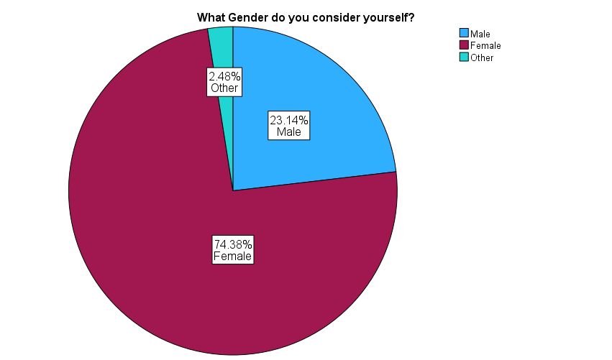

We note that approximately 74% of people that shop at Target are mainly Female, this is not consistent with the population, as shown on p. 27 of this report.

Which of the following best describes your reason for choosing to shop at Target over other stores?
 |  | Frequency | Percent | Valid Percent | Cumulative Percent
Valid | Prices | 17 | 7.0 | 7.1 | 7.1
Valid | In Store Shopping Experience | 47 | 19.4 | 19.7 | 26.8
Valid | Customer Service | 3 | 1.2 | 1.3 | 28.0
Valid | Location | 37 | 15.3 | 15.5 | 43.5
Valid | Product Selection | 135 | 55.8 | 56.5 | 100.0
Valid | Total | 239 | 98.8 | 100.0
Missing | System | 3 | 1.2
Total |  | 242 | 100.0

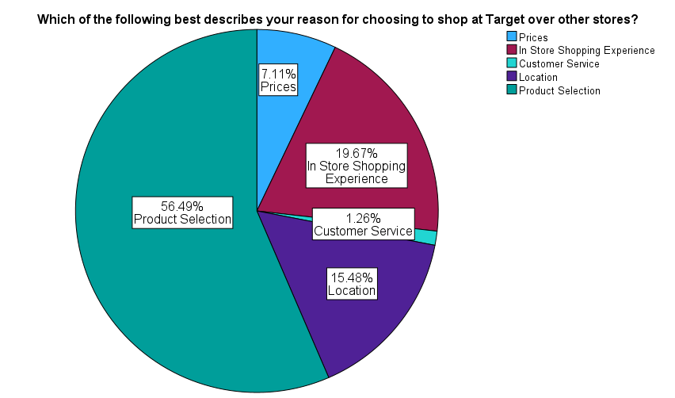

The data indicates that product selection is the primary reason customers choose to shop at Target, with 56.49% of respondents identifying it as their main reason. The item evaluating preferences for Target over other retailers had a mean score of 3.95 on a 5-point scale, which supports this. Additional noteworthy factors include the in-store shopping experience (19.67%) and store location (15.48%), both of which are indicative of Target's focus on consumer convenience and fostering a positive atmosphere. On the other hand, just 1.26% of respondents said that their primary reason for selecting Target was the company's customer service, which was placed lowest.

Managerial Conclusion: Target should keep emphasizing its wide range of products while making sure it stays different from rivals in order to preserve its competitive edge. Enhancing customer service, which came in last on the list of reasons to shop at Target, could draw in more customers and improve the shopping experience.

I shop at Target because the location is convenient.
 |  | Frequency | Percent | Valid Percent | Cumulative Percent
Valid | Strongly Disagree | 16 | 6.6 | 6.6 | 6.6
Valid | Somewhat Disagree | 17 | 7.0 | 7.0 | 13.6
Valid | Neither Agree nor Disagree | 48 | 19.8 | 19.8 | 33.5
Valid | Somewhat Agree | 97 | 40.1 | 40.1 | 73.6
Valid | Strongly Agree | 64 | 26.4 | 26.4 | 100.0
Valid | Total | 242 | 100.0 | 100.0

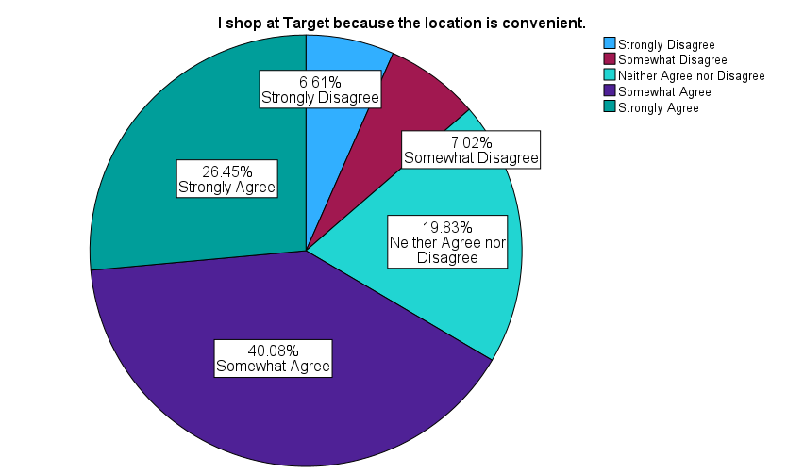

The data shows that 66.5% of respondents somewhat agree or strongly agree that Target’s locations are convenient, with a mean score of 3.73 on a 5-point scale. A smaller portion, 13.6%, expressed disagreement, and 19.8% remained neutral. This reflects a majority of customers acknowledging Target’s accessibility, but there is room to address specific location concerns among those who are dissatisfied.
Managerial Conclusion: Given that most respondents find locations convenient, Target's site selection is effective. Target might, however, think about reaching underserved areas, such suburban or rural areas, to increase customer happiness. Targeted advertising in areas that are neutral or unsatisfied may also improve convenience perceptions.
Note to Reviewers: Each variable has been analyzed in detail for the sake of completeness. If you would like to skip directly to the hypothesis tests, chi-squared tests, correlation, and regression, please Go To (Ctrl+G) p. 28.

I am satisfied with the variety of items being offered at Target.
 |  | Frequency | Percent | Valid Percent | Cumulative Percent
Valid | Strongly Disagree | 11 | 4.5 | 4.5 | 4.5
Valid | Somewhat Disagree | 11 | 4.5 | 4.5 | 9.1
Valid | Neither Agree nor Disagree | 26 | 10.7 | 10.7 | 19.8
Valid | Somewhat Agree | 94 | 38.8 | 38.8 | 58.7
Valid | Strongly Agree | 100 | 41.3 | 41.3 | 100.0
Valid | Total | 242 | 100.0 | 100.0

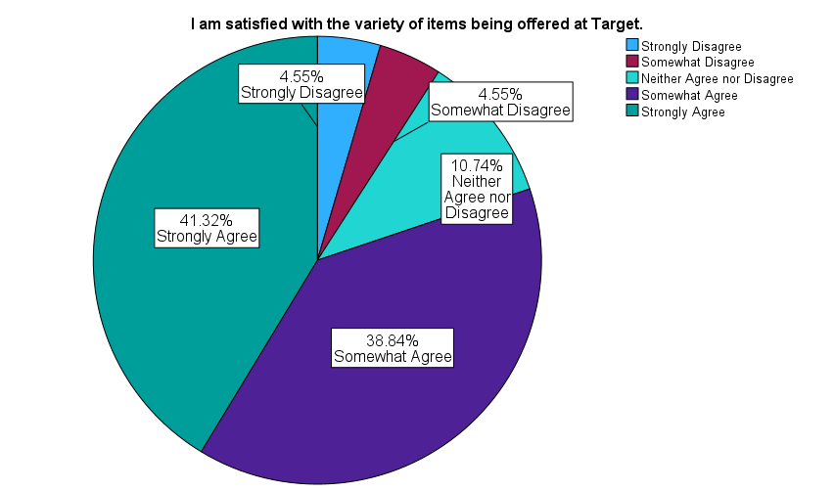

Approximately 80.1% of respondents somewhat or strongly agreed that they were satisfied with the variety of items offered at Target, resulting in a high mean score of 4.08 on a 5-point scale. Only approximately 9% expressed disagreement, and 10.74% were neutral. These results indicate strong approval for Target's product diversity, with opportunities for further improvement.

Managerial Conclusion: Target should keep concentrating on providing a large range of goods that satisfy various consumer tastes. Target may think about launching specialized or niche products to appeal to the 10.7% of respondents who expressed no opinion. There isn't much dispute, but consistently growing product lines could increase client happiness and keep them loyal.

The employees at Target offer excellent customer service.
 |  | Frequency | Percent | Valid Percent | Cumulative Percent
Valid | Strongly Disagree | 4 | 1.7 | 1.7 | 1.7
Valid | Somewhat Disagree | 13 | 5.4 | 5.4 | 7.0
Valid | Neither Agree nor Disagree | 76 | 31.4 | 31.4 | 38.4
Valid | Somewhat Agree | 77 | 31.8 | 31.8 | 70.2
Valid | Strongly Agree | 72 | 29.8 | 29.8 | 100.0
Valid | Total | 242 | 100.0 | 100.0

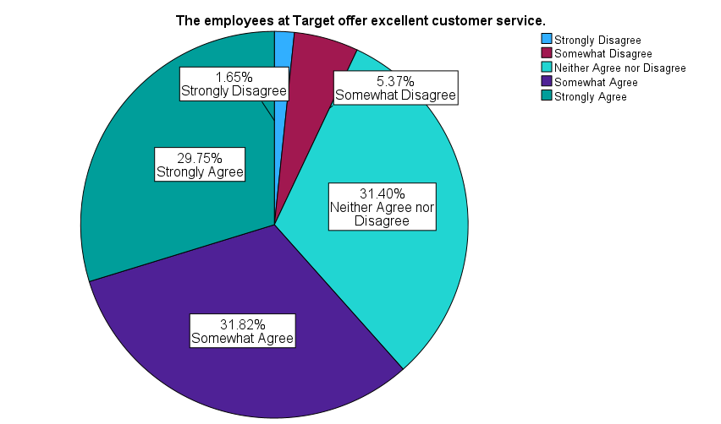

The survey shows that 61.6% of respondents somewhat or strongly agreed that Target employees provide excellent customer service, yielding a mean score of 3.83 on a 5-point scale. While 31.4% were neutral, only 7% expressed dissatisfaction. These results highlight a generally positive perception of Target’s customer service.

Managerial Conclusion: The fact that most people feel that Target's customer service training is excellent shows how effective it is. Additional training in proactive involvement and individualized assistance could improve the entire shopping experience in order to address the neutral responses. Although the low level of discontent indicates that Target is doing well in this area, it might yet enhance its service strategy.

The items offered at Target are competitively priced.
 |  | Frequency | Percent | Valid Percent | Cumulative Percent
Valid | Strongly Disagree | 16 | 6.6 | 6.6 | 6.6
Valid | Somewhat Disagree | 49 | 20.2 | 20.2 | 26.9
Valid | Neither Agree nor Disagree | 67 | 27.7 | 27.7 | 54.5
Valid | Somewhat Agree | 70 | 28.9 | 28.9 | 83.5
Valid | Strongly Agree | 40 | 16.5 | 16.5 | 100.0
Valid | Total | 242 | 100.0 | 100.0

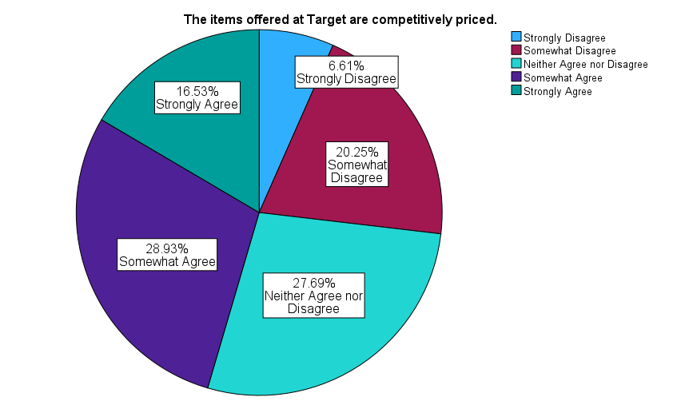

Only 45.4% of respondents somewhat or strongly agreed that Target’s items are competitively priced, with a mean score of 3.29 on a 5-point scale. A significant 26.8% disagreed, and 27.7% were neutral. These findings suggest pricing perceptions are divided among customers.
Managerial Conclusion: Target should aggressively compare its prices to those of its rivals and use advertising campaigns to highlight the worth of its goods. The 27.7% of respondents who were neutral could be persuaded and the perception of competitive pricing enhanced by emphasizing affordability and providing calculated discounts.

I would choose shopping at Target over Walmart.
 |  | Frequency | Percent | Valid Percent | Cumulative Percent
Valid | Strongly Disagree | 57 | 23.6 | 23.6 | 23.6
Valid | Somewhat Disagree | 40 | 16.5 | 16.5 | 40.1
Valid | Neither Agree nor Disagree | 49 | 20.2 | 20.2 | 60.3
Valid | Somewhat Agree | 34 | 14.0 | 14.0 | 74.4
Valid | Strongly Agree | 62 | 25.6 | 25.6 | 100.0
Valid | Total | 242 | 100.0 | 100.0

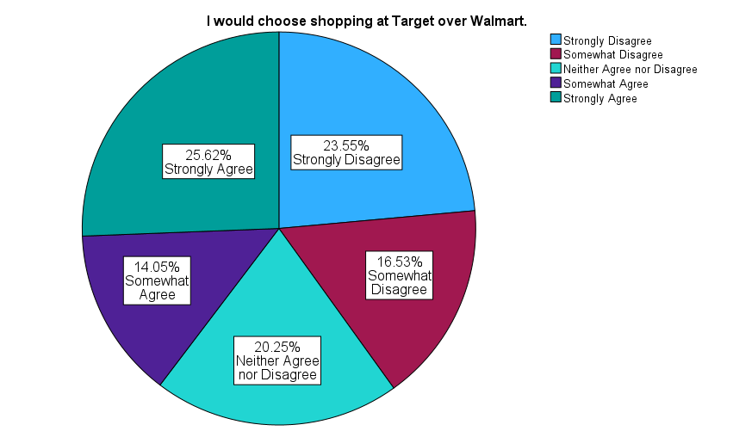

The data shows that 39.7% of respondents somewhat or strongly agreed they would choose Target over Walmart, while 40.1% disagreed, resulting in a mean score of 3.02 on a 5-point scale. Neutral responses accounted for 20.2%, showing mixed opinions about Target’s position relative to Walmart.
Managerial Conclusion: To find areas for development, Target could examine Walmart's advantages, such as its choice of groceries and prices. Customers who now choose Walmart may be drawn to Target by improved marketing campaigns that highlight its distinctive features, such as social responsibility and high-quality products.

I would choose shopping at Target over Kroger.
 |  | Frequency | Percent | Valid Percent | Cumulative Percent
Valid | Strongly Disagree | 60 | 24.8 | 24.9 | 24.9
Valid | Somewhat Disagree | 51 | 21.1 | 21.2 | 46.1
Valid | Neither Agree nor Disagree | 53 | 21.9 | 22.0 | 68.0
Valid | Somewhat Agree | 34 | 14.0 | 14.1 | 82.2
Valid | Strongly Agree | 43 | 17.8 | 17.8 | 100.0
Valid | Total | 241 | 99.6 | 100.0
Missing | System | 1 | .4
Total |  | 242 | 100.0

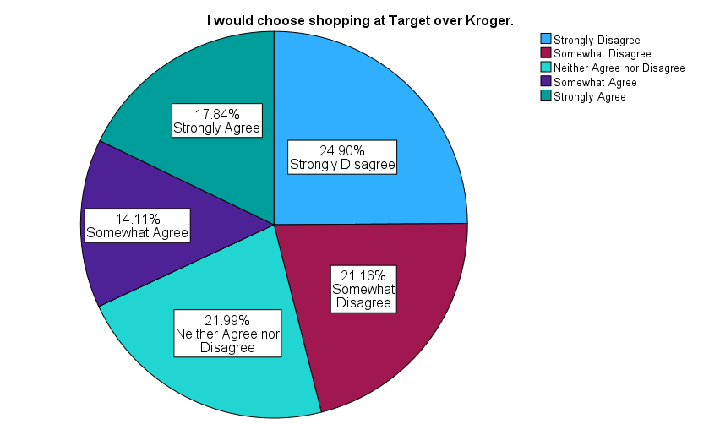

The data reveals that only 31.9% of respondents somewhat or strongly agreed they would choose Target over Kroger, while 46.1% disagreed. Neutral responses made up 22%, and the mean score was 2.79 on a 5-point scale. These results indicate a strong preference for Kroger among respondents.
Managerial Conclusion: Target might add fresh produce and unique items to their grocery selection in order to more effectively compete with Kroger. It may also draw in additional business to highlight the ease of one-stop shopping that includes both food and non-grocery items. Promoting these benefits could sway ambivalent respondents and strengthen Target's standing.
Target’s commitment to social responsibility (e.g., community engagement, sustainability) is a key factor in my decision to shop there.
 |  | Frequency | Percent | Valid Percent | Cumulative Percent
Valid | Strongly Disagree | 57 | 23.6 | 23.7 | 23.7
Valid | Somewhat Disagree | 32 | 13.2 | 13.3 | 36.9
Valid | Neither Agree nor Disagree | 93 | 38.4 | 38.6 | 75.5
Valid | Somewhat Agree | 28 | 11.6 | 11.6 | 87.1
Valid | Strongly Agree | 31 | 12.8 | 12.9 | 100.0
Valid | Total | 241 | 99.6 | 100.0
Missing | System | 1 | .4
Total |  | 242 | 100.0

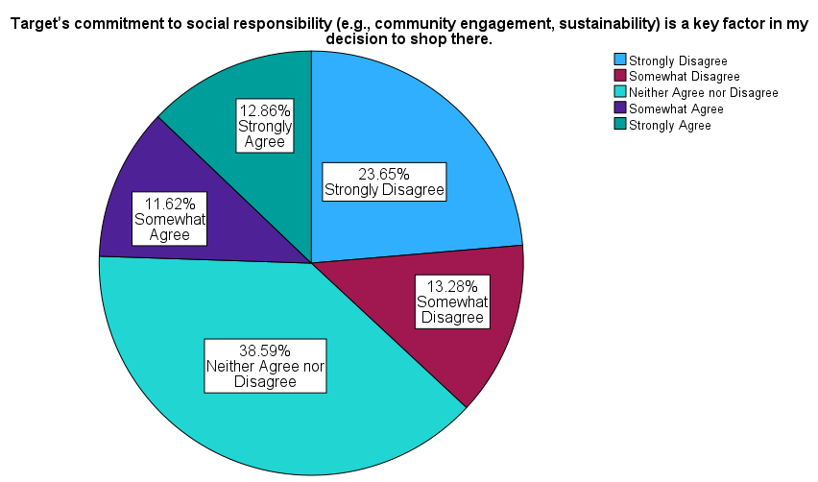

The data shows that only 24.5% of respondents somewhat or strongly agreed that Target’s social responsibility is a key factor in their decision to shop there. Meanwhile, 37% disagreed, and 38.6% remained neutral, with a mean score of 2.77 on a 5-point scale. This suggests that many customers are either unaware of or unconvinced by Target’s sustainability and community engagement efforts.

Managerial Conclusion: Target has to make its community involvement and sustainability efforts more widely known. In-store advertising, social media initiatives, and collaborations with neighborhood organizations could raise consumer awareness and change the opinions of neutral responders. Better communication in this area might potentially draw in environmentally conscientious consumers.

I use Target’s mobile app or website for shopping and browsing.
 |  | Frequency | Percent | Valid Percent | Cumulative Percent
Valid | Strongly Disagree | 92 | 38.0 | 38.0 | 38.0
Valid | Somewhat Disagree | 14 | 5.8 | 5.8 | 43.8
Valid | Neither Agree nor Disagree | 26 | 10.7 | 10.7 | 54.5
Valid | Somewhat Agree | 28 | 11.6 | 11.6 | 66.1
Valid | Strongly Agree | 82 | 33.9 | 33.9 | 100.0
Valid | Total | 242 | 100.0 | 100.0

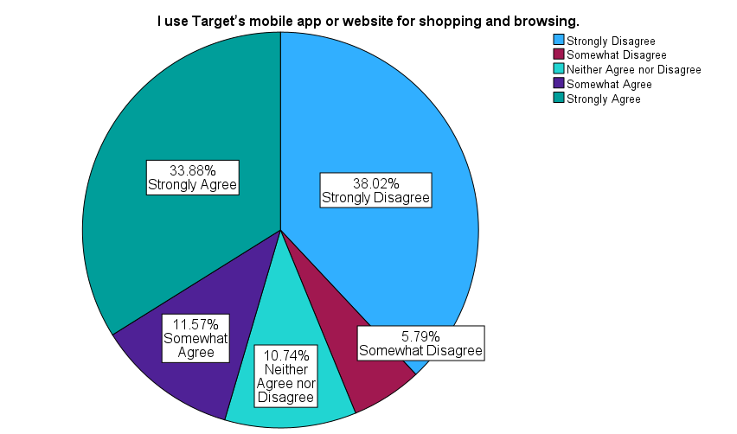

The survey reveals that 45.5% of respondents somewhat or strongly agreed they use Target’s mobile app or website, while 43.8% disagreed. Neutral responses accounted for 10.7%, and the mean score was 2.93 on a 5-point scale. This indicates a relatively balanced split between users and non-users of Target’s online platforms.
Managerial Conclusion: Target could boost up its marketing initiatives to encourage more people to use its website and app. More customers may use these digital tools if tactics like providing app-only discounts, simplifying the online buying process, and emphasizing features like order tracking are used.

I am satisfied with Target’s in-store shopping experience.
 |  | Frequency | Percent | Valid Percent | Cumulative Percent
Valid | Strongly Disagree | 4 | 1.7 | 1.7 | 1.7
Valid | Somewhat Disagree | 7 | 2.9 | 2.9 | 4.5
Valid | Neither Agree nor Disagree | 36 | 14.9 | 14.9 | 19.4
Valid | Somewhat Agree | 93 | 38.4 | 38.4 | 57.9
Valid | Strongly Agree | 102 | 42.1 | 42.1 | 100.0
Valid | Total | 242 | 100.0 | 100.0

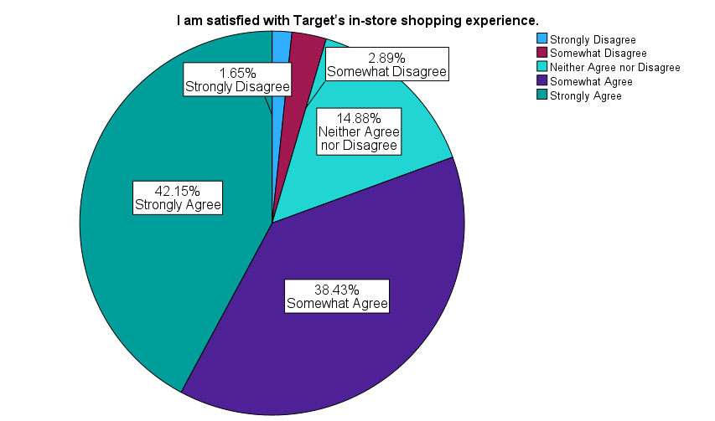

Approximately 80.6% of respondents somewhat or strongly agreed they were satisfied with Target’s in-store shopping experience, yielding a high mean score of 4.17 on a 5-point scale. Only 4.5% expressed dissatisfaction, and 14.9% were neutral. These results demonstrate strong approval for Target’s in-store environment.

Managerial Conclusion: Target should keep emphasizing the in-store shopping experience by maintaining neat layouts, welcoming employees, and eye-catching displays. Neutral clients could be engaged and the experience further improved with extra elements like interactive kiosks or in-store activities.

I always find what I am looking for at Target.
 |  | Frequency | Percent | Valid Percent | Cumulative Percent
Valid | Strongly Disagree | 11 | 4.5 | 4.5 | 4.5
Valid | Somewhat Disagree | 31 | 12.8 | 12.8 | 17.4
Valid | Neither Agree nor Disagree | 50 | 20.7 | 20.7 | 38.0
Valid | Somewhat Agree | 101 | 41.7 | 41.7 | 79.8
Valid | Strongly Agree | 49 | 20.2 | 20.2 | 100.0
Valid | Total | 242 | 100.0 | 100.0

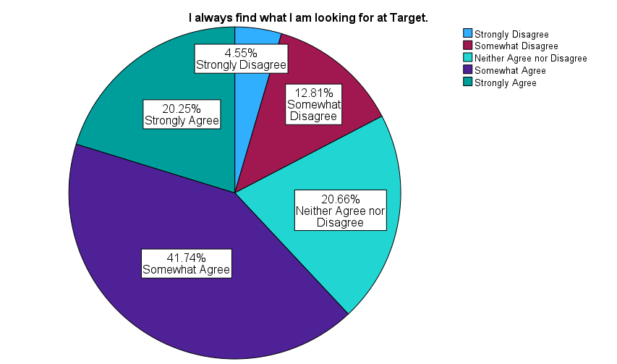

The data shows that 62% of respondents somewhat or strongly agreed they always find what they are looking for at Target, with a mean score of 3.60 on a 5-point scale. In contrast, 17.4% disagreed, and 20.7% were neutral.
Managerial Conclusion: The concerns of indifferent and unsatisfied respondents could be addressed by enhancing inventory management and store navigation, even though the majority of respondents find what they need. The shopping experience could be improved by putting in place clear signage and guaranteeing constant supply availability.

I regularly shop at Target for groceries.
 |  | Frequency | Percent | Valid Percent | Cumulative Percent
Valid | Strongly Disagree | 154 | 63.6 | 63.6 | 63.6
Valid | Somewhat Disagree | 45 | 18.6 | 18.6 | 82.2
Valid | Neither Agree nor Disagree | 22 | 9.1 | 9.1 | 91.3
Valid | Somewhat Agree | 15 | 6.2 | 6.2 | 97.5
Valid | Strongly Agree | 6 | 2.5 | 2.5 | 100.0
Valid | Total | 242 | 100.0 | 100.0

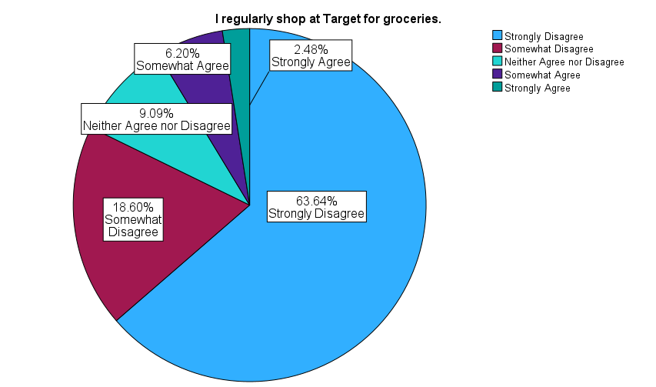

An overwhelming 82.2% of respondents disagreed that they regularly shop at Target for groceries, resulting in a low mean score of 1.65 on a 5-point scale. Only 8.7% somewhat or strongly agreed.

Managerial Conclusion: Target should choose whether to concentrate more on non-grocery products, where it excels, or broaden its grocery selection to compete with retailers like Kroger. Promoting novel, fresh products and stressing convenience may draw in more customers if groceries continue to be a top concern.

I would recommend Target to my friends.
 |  | Frequency | Percent | Valid Percent | Cumulative Percent
Valid | Strongly Disagree | 10 | 4.1 | 4.1 | 4.1
Valid | Somewhat Disagree | 9 | 3.7 | 3.7 | 7.9
Valid | Neither Agree nor Disagree | 55 | 22.7 | 22.7 | 30.6
Valid | Somewhat Agree | 81 | 33.5 | 33.5 | 64.0
Valid | Strongly Agree | 87 | 36.0 | 36.0 | 100.0
Valid | Total | 242 | 100.0 | 100.0

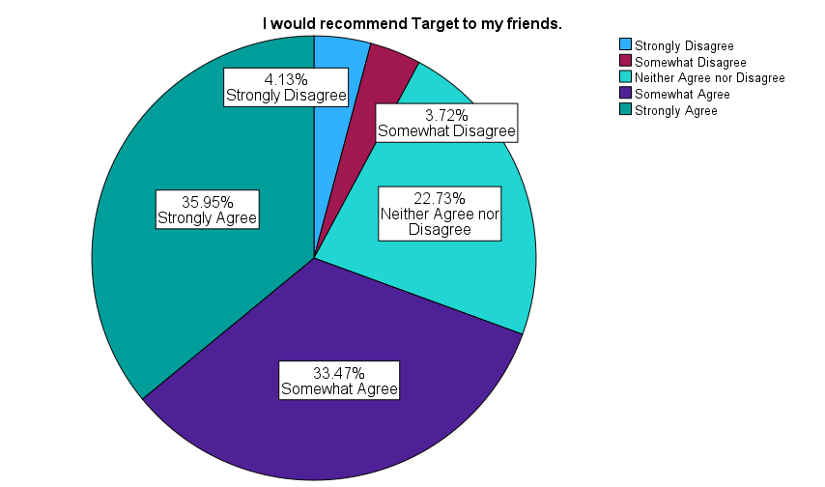

Approximately 69.4% of respondents somewhat or strongly agreed they would recommend Target to their friends, resulting in a mean score of 3.93 on a 5-point scale. Only 7.9% disagreed, and 22.7% were neutral.

Managerial Conclusion: Target should keep putting a strong emphasis on loyalty programs and customer satisfaction in order to promote goodwill. Recommendation rates may rise if neutral consumers are engaged with referral incentives or by emphasizing special product offerings.

Target meets my expectations and needs more than most stores.
 |  | Frequency | Percent | Valid Percent | Cumulative Percent
Valid | Strongly Disagree | 22 | 9.1 | 9.1 | 9.1
Valid | Somewhat Disagree | 37 | 15.3 | 15.3 | 24.4
Valid | Neither Agree nor Disagree | 61 | 25.2 | 25.2 | 49.6
Valid | Somewhat Agree | 68 | 28.1 | 28.1 | 77.7
Valid | Strongly Agree | 54 | 22.3 | 22.3 | 100.0
Valid | Total | 242 | 100.0 | 100.0

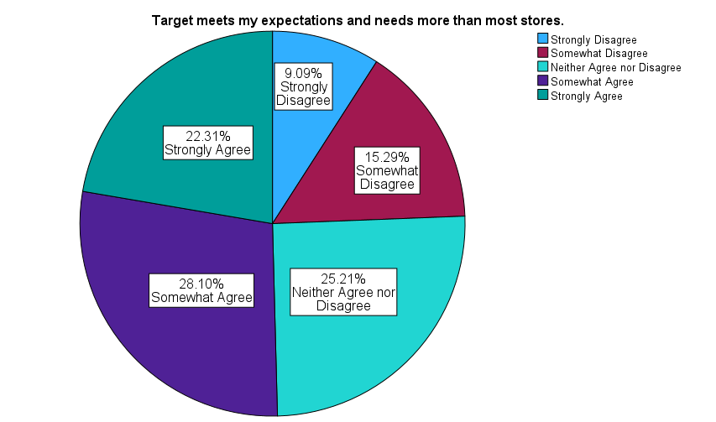

The survey reveals that 50.4% of respondents somewhat or strongly agreed that Target meets their expectations and needs, while 24.4% disagreed. Neutral responses accounted for 25.2%, with a mean score of 3.39 on a 5-point scale.

Managerial Conclusion: Target should address the 24.4% of respondents who indicated unhappiness by employing targeted surveys to identify unmet needs. Increasing product diversity or enhancing customer service might help meet expectations and convert ambivalent or dissatisfied customers.

I can find products easier in Target than in most stores.
 |  | Frequency | Percent | Valid Percent | Cumulative Percent
Valid | Strongly Disagree | 15 | 6.2 | 6.2 | 6.2
Valid | Somewhat Disagree | 32 | 13.2 | 13.2 | 19.4
Valid | Neither Agree nor Disagree | 58 | 24.0 | 24.0 | 43.4
Valid | Somewhat Agree | 90 | 37.2 | 37.2 | 80.6
Valid | Strongly Agree | 47 | 19.4 | 19.4 | 100.0
Valid | Total | 242 | 100.0 | 100.0

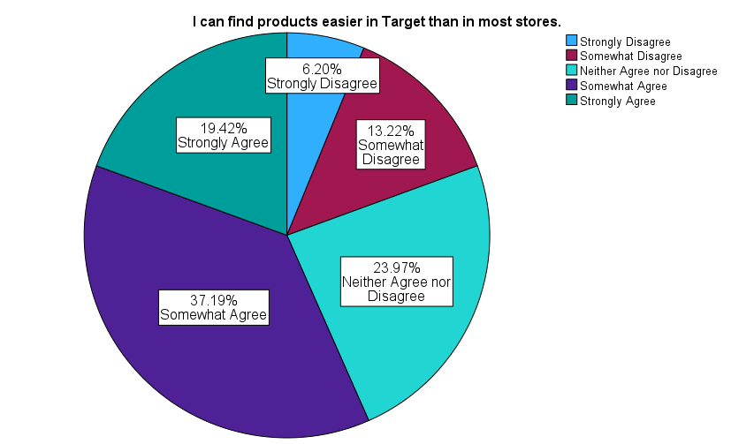

The data shows that 56.6% of respondents somewhat or strongly agreed they can easily find products at Target, with a mean score of 3.50 on a 5-point scale. In contrast, 19.4% disagreed, and 24% were neutral.
Managerial Conclusion: Although most people find things quickly, indifferent and unsatisfied respondents may have problems that might be addressed by enhancing store layouts, signage, and aisle organization. Additionally, the buying experience may be improved by digital technologies like in-app navigation.

I am satisfied with Target’s order pickup process.
 |  | Frequency | Percent | Valid Percent | Cumulative Percent
Valid | Strongly Disagree | 4 | 1.7 | 1.7 | 1.7
Valid | Somewhat Disagree | 3 | 1.2 | 1.2 | 2.9
Valid | Neither Agree nor Disagree | 125 | 51.7 | 51.7 | 54.5
Valid | Somewhat Agree | 29 | 12.0 | 12.0 | 66.5
Valid | Strongly Agree | 81 | 33.5 | 33.5 | 100.0
Valid | Total | 242 | 100.0 | 100.0

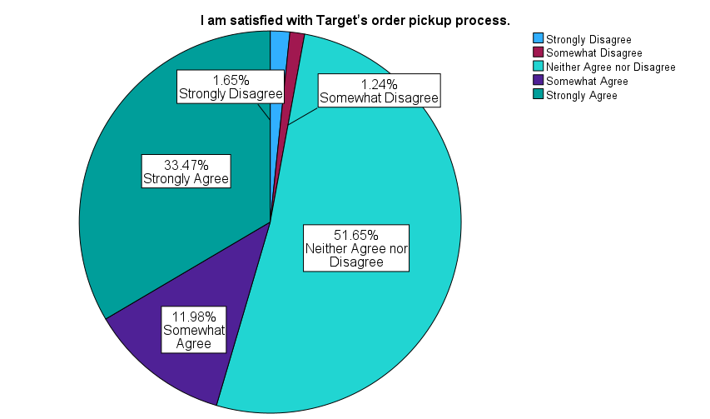

Approximately 45.5% of respondents somewhat or strongly agreed they were satisfied with Target’s order pickup process, while 51.6% were neutral. Only 2.9% expressed dissatisfaction, with a mean score of 3.74 on a 5-point scale.
Managerial Conclusion: Neutral consumers may become advocates by highlighting the advantages of order pickup and providing special incentives. Resolving complaints about wait times or the precision of pickups may also increase customer satisfaction.

Target meets all of my shopping needs.
 |  | Frequency | Percent | Valid Percent | Cumulative Percent
Valid | Strongly Disagree | 31 | 12.8 | 12.8 | 12.8
Valid | Somewhat Disagree | 42 | 17.4 | 17.4 | 30.2
Valid | Neither Agree nor Disagree | 61 | 25.2 | 25.2 | 55.4
Valid | Somewhat Agree | 67 | 27.7 | 27.7 | 83.1
Valid | Strongly Agree | 41 | 16.9 | 16.9 | 100.0
Valid | Total | 242 | 100.0 | 100.0

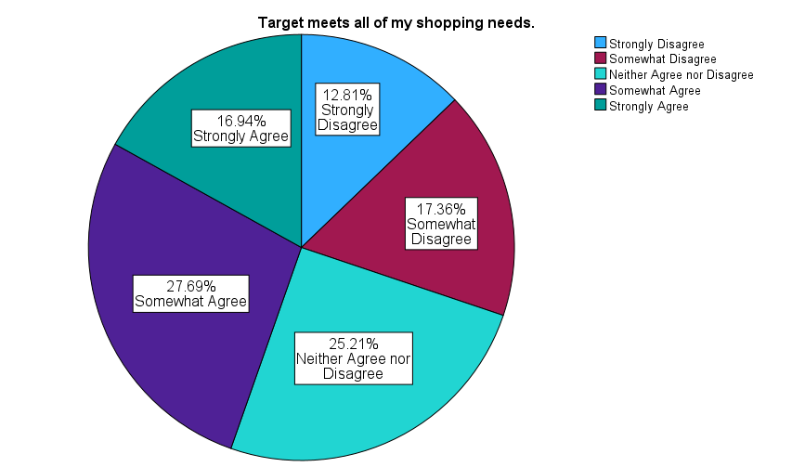
The data shows that 44.6% of respondents somewhat or strongly agreed Target meets all their shopping needs, while 30.2% disagreed. Neutral responses accounted for 25.2%, and the mean score was 3.19 on a 5-point scale.
Managerial Conclusion: Enhancing availability or diversifying product lines could better satisfy consumer demands. In order to fill in the gaps in customer expectations and entice indifferent shoppers, Target may also think about tailored marketing.

Target stores are clean and organized.
 |  | Frequency | Percent | Valid Percent | Cumulative Percent
Valid | Strongly Disagree | 3 | 1.2 | 1.2 | 1.2
Valid | Somewhat Disagree | 10 | 4.1 | 4.1 | 5.4
Valid | Neither Agree nor Disagree | 18 | 7.4 | 7.4 | 12.8
Valid | Somewhat Agree | 78 | 32.2 | 32.2 | 45.0
Valid | Strongly Agree | 133 | 55.0 | 55.0 | 100.0
Valid | Total | 242 | 100.0 | 100.0

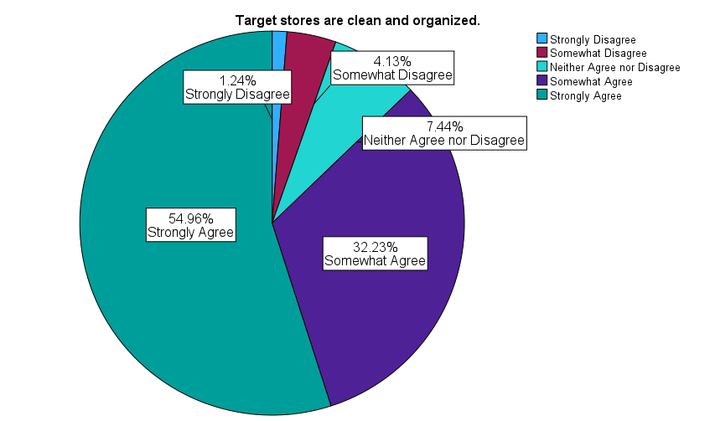

An impressive 87.2% of respondents somewhat or strongly agreed that Target stores are clean and organized, with a mean score of 4.36 on a 5-point scale. Only 5.3% disagreed, and 7.4% were neutral.
Managerial Conclusion: Target should continue to uphold its excellent standards for organization and cleanliness. Promoting this power as a component of the business image could draw in new clients while guaranteeing that current ones remain satisfied.

I regularly use the Target online deals.
 |  | Frequency | Percent | Valid Percent | Cumulative Percent
Valid | Strongly Disagree | 72 | 29.8 | 29.8 | 29.8
Valid | Somewhat Disagree | 25 | 10.3 | 10.3 | 40.1
Valid | Neither Agree nor Disagree | 46 | 19.0 | 19.0 | 59.1
Valid | Somewhat Agree | 45 | 18.6 | 18.6 | 77.7
Valid | Strongly Agree | 54 | 22.3 | 22.3 | 100.0
Valid | Total | 242 | 100.0 | 100.0

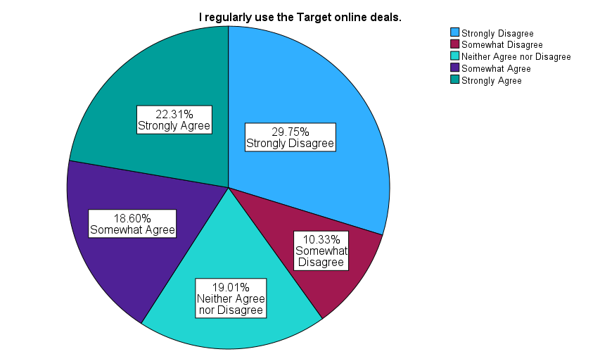

Only 40.9% of respondents somewhat or strongly agreed they regularly use Target’s online deals, while 40.1% disagreed. Neutral responses accounted for 19%, and the mean score was 2.93 on a 5-point scale.
Managerial Conclusion: More interaction may result from making online discounts more visible through targeted notifications, app promotions, or special website areas. Targeted advertising that highlights savings could influence respondents who are neutral or dissatisfied.

I am satisfied with Target’s online shopping experience.
 |  | Frequency | Percent | Valid Percent | Cumulative Percent
Valid | Strongly Disagree | 9 | 3.7 | 3.7 | 3.7
Valid | Somewhat Disagree | 7 | 2.9 | 2.9 | 6.6
Valid | Neither Agree nor Disagree | 100 | 41.3 | 41.3 | 47.9
Valid | Somewhat Agree | 50 | 20.7 | 20.7 | 68.6
Valid | Strongly Agree | 76 | 31.4 | 31.4 | 100.0
Valid | Total | 242 | 100.0 | 100.0

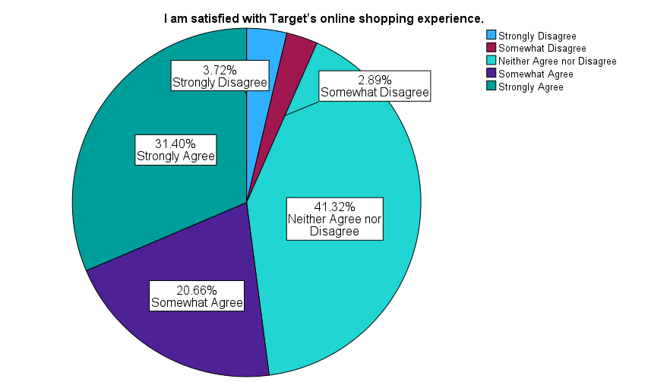

Approximately 52.1% of respondents somewhat or strongly agreed they are satisfied with Target’s online shopping experience, while 41.3% were neutral. Only 6.6% expressed dissatisfaction, with a mean score of 3.73 on a 5-point scale.
Managerial Conclusion: Improving features like product descriptions, expedited shipping choices, and easy-to-use website navigation may turn indifferent responders into devoted online buyers. Having clear communication about policies could increase satisfaction even further.

Overall, shopping at Target is an enjoyable experience.
 |  | Frequency | Percent | Valid Percent | Cumulative Percent
Valid | Strongly Disagree | 3 | 1.2 | 1.2 | 1.2
Valid | Somewhat Disagree | 4 | 1.7 | 1.7 | 2.9
Valid | Neither Agree nor Disagree | 38 | 15.7 | 15.7 | 18.6
Valid | Somewhat Agree | 90 | 37.2 | 37.2 | 55.8
Valid | Strongly Agree | 107 | 44.2 | 44.2 | 100.0
Valid | Total | 242 | 100.0 | 100.0

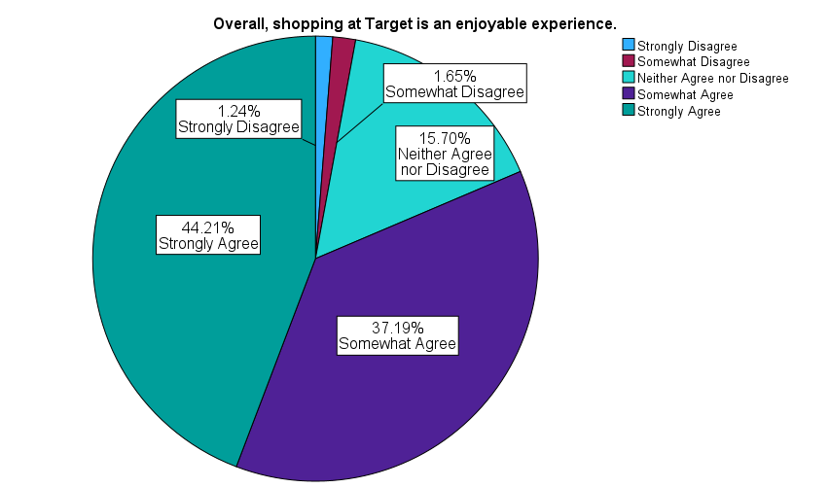

The survey shows that 81.4% of respondents somewhat or strongly agreed that shopping at Target is enjoyable, with a high mean score of 4.21 on a 5-point scale. Only 2.9% expressed dissatisfaction, and 15.7% were neutral.
Managerial Conclusion: Target should keep making investments to provide customers with pleasurable shopping experiences by using attractive store designs, helpful employees, and premium goods. Prioritizing consistently satisfying experiences can increase client retention and draw in new business.

Bar Charts

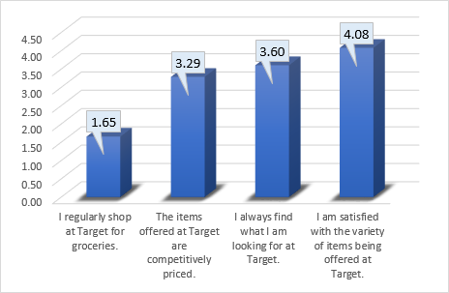
This bar chart shows how customers feel and behave when they purchase at Target in-store. Important revelations include:
- The low average score of 1.65 for "I regularly shop at Target for groceries," indicates that people do not visit Target primarily for grocery shopping.
- The phrases "I always find what I am looking for at Target" (3.60) and "The items offered at Target are competitively priced" (3.29) received somewhat high ratings. These findings suggest that opinions about product availability and cost are largely favorable.
- The statement, "I am satisfied with the variety of items being offered at Target," received the highest score (4.08), indicating that customers are happy with Target's wide range of products. The hypothesis test of one mean shown on p.30 proves that this value is insignificantly different from 4.

Managerial Conclusion: Target should think about ways to boost grocery shopping engagement in-store, as this element received a significantly lower score than others. Increased foot traffic and customer loyalty could result from extending promotions or improving the grocery shopping experience. Marketing campaigns should also highlight the high level of satisfaction with product availability and variety.

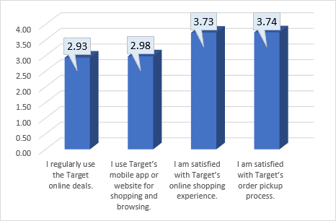
This bar graph is centered on customer usage and satisfaction with Target's online purchasing platforms and services. The highlights of this bar chart are:
- "I regularly use the Target online deals" (2.93) and "I use Target’s mobile app or website for shopping and browsing" (2.98) received relatively low scores. This shows that Target's digital channels are not being used to their full potential. The hypothesis tests of one mean on p.29 proves that these values are significantly more than 2 but are significantly less than 3
- "I am satisfied with Target's online shopping experience" (3.73) and "I am satisfied with Target’s order pickup process" (3.74) have higher satisfaction ratings, suggesting that customers are very happy with these services.
Managerial Conclusion: The goal of online shopping should be to increase consumer interaction with Target's digital channels. Targeted advertisements that raise knowledge of online sales and app features may encourage greater use. Given the high level of satisfaction with the online shopping and order pickup procedures, Target may be able to improve its competitive position by bolstering these services with further features or incentives.

Hypothesis test of the Proportion of Females:
H_{o}: P = 0.625
H_{a}: P ≠ 0.625
Step 1. H_{o}: P = P_{o}; H_{a}: P ≠ P_{o} (Po is the proportion of females in the population at UWG)
Step 2. z_{c} = (p-P_{o}) / S_{p}; where S_{p} = SqRt. [((P_{o} x (1-P_{o}) )/n]
Step 3. z_{t} from table = ± 1.96 (α = 0.05)
Step 4. S_{p} = SqRt.[((0.625 x (1-0.625))/242] = 0.031
z_{c} = (0.744-0.625)/0.031 = 3.839
Therefore, we Reject H_{o} and conclude that our proportions of females is significantly different from those of the UWG population in terms of Gender.

T-Tests or Hypothesis Tests
Hypothesis Tests: Tests of One Mean:
One-Sample Statistics
 | N |  |  | Mean |  |  | Std. Deviation |  |  | Std. Error Mean
I can find products easier in Target than in most stores. | 242 |  |  | 3.50 |  |  | 1.131 |  |  | .073
I am satisfied with Target’s order pickup process. | 242 |  |  | 3.74 |  |  | .994 |  |  | .064
Target meets all of my shopping needs. | 242 |  |  | 3.19 |  |  | 1.270 |  |  | .082
Target stores are clean and organized. | 242 |  |  | 4.36 |  |  | .882 |  |  | .057
I regularly use the Target online deals. | 242 |  |  | 2.93 |  |  | 1.542 |  |  | .099
Test Value = 3
 |  | t |  |  | Significance
 |  |  |  |  | One-Sided p |  |  |  | Two-Sided p
I can find products easier in Target than in most stores. |  | 6.932 |  |  | <.001 |  |  |  | <.001
I am satisfied with Target’s order pickup process. |  | 11.641 |  |  | <.001 |  |  |  | <.001
Target meets all of my shopping needs. |  | 2.278 |  |  | .012 |  |  |  | .024
Target stores are clean and organized. |  | 23.908 |  |  | <.001 |  |  |  | <.001
I regularly use the Target online deals. |  | -.667 |  |  | .253 |  |  |  | .505
Test Value = 4
 |  |  | t |  |  | Significance
 |  |  |  |  |  | One-Sided p |  | Two-Sided p
I can find products easier in Target than in most stores. |  |  | -6.818 |  |  | <.001 |  | <.001
I am satisfied with Target’s order pickup process. |  |  | -4.010 |  |  | <.001 |  | <.001
Target meets all of my shopping needs. |  |  | -9.972 |  |  | <.001 |  | <.001
Target stores are clean and organized. |  |  | 6.269 |  |  | <.001 |  | <.001
I regularly use the Target online deals. |  |  | -10.756 |  |  | <.001 |  | <.001

The following variables had means significantly greater than 4:
- Target stores are clean and organized.
The following variables had means insignificantly different from 4:
- None
The following variables had means significantly less than 4, but significantly greater than 3:
- I am satisfied with Target’s order pickup process.
- Target meets all of my shopping needs.
- I can find products easier in Target than in most stores.
The following variables had means insignificantly different from 3:
- I regularly use the Target online deals.
The following variables had means significantly less than 3:
- None
Managerial Conclusions: Target stores are clean and organized. Target is doing very well in this dimension because it has a mean significantly greater than 4. However, the order pickup process at Target, and the arrangement of products need a little bit of improvement to aid customers with finding their desired products. Target also needs to meet the shopping needs of more customers. Online deals need to be improved significantly as well.
One-Sample Statistics
 | N | Mean | Std. Deviation | Std. Error Mean
I am satisfied with the variety of items being offered at Target. | 242 | 4.08 | 1.054 | .068
The employees at Target offer excellent customer service. | 242 | 3.83 | .974 | .063
The items offered at Target are competitively priced. | 242 | 3.29 | 1.158 | .074
I am satisfied with Target’s in-store shopping experience. | 242 | 4.17 | .900 | .058

One-Sample Tests
Test Value = 3
Test Value = 3 | t |  | Significance
Test Value = 3 |  |  | One-Sided p |  | Two-Sided p
I am satisfied with the variety of items being offered at Target. | 15.925 |  | <.001 |  | <.001
The employees at Target offer excellent customer service. | 13.197 |  | <.001 |  | <.001
The items offered at Target are competitively priced. | 3.829 |  | <.001 |  | <.001
I am satisfied with Target’s in-store shopping experience. | 20.133 |  | <.001 |  | <.001
Test Value = 4
 |  | t |  | Significance
 |  |  |  | One-Sided p |  | Two-Sided p
I am satisfied with the variety of items being offered at Target. |  | 1.159 |  | .124 |  | .247
The employees at Target offer excellent customer service. |  | -2.771 |  | .003 |  | .006
The items offered at Target are competitively priced. |  | -9.601 |  | <.001 |  | <.001
I am satisfied with Target’s in-store shopping experience. |  | 2.856 |  | .002 |  | .005

The following variables had means significantly greater than 4:
- I am satisfied with Target’s in-store shopping experience.
The following variables had means insignificantly different from 4:
- I am satisfied with the variety of items being offered at Target.
The following variables had means significantly less than 4, but significantly greater than 3:
- The employees at Target offer excellent customer service.
- The items offered at Target are competitively priced.
The following variables had means insignificantly different from 3:
- None
The following variables had means significantly less than 3:
- None
Managerial Conclusions: Target patrons are very satisfied with the in-store shopping experience. The variety of items could be improved a little more, but in general, a lot of people are satisfied with them. However, the pricing of items at Target, as well as the customer service at Target need improvement.

Tests of Differences Between Means:
Group Statistics
 | What Gender do you consider yourself? | N | Mean | Std. Deviation | Std. Error Mean
I am satisfied with the variety of items being offered at Target. | Male | 56 | 4.16 | .826 | .110
 | Female | 180 | 4.10 | 1.068 | .080
The employees at Target offer excellent customer service. | Male | 56 | 4.09 | .920 | .123
The employees at Target offer excellent customer service. | Female | 180 | 3.76 | .965 | .072
The items offered at Target are competitively priced. | Male | 56 | 3.48 | 1.128 | .151
The items offered at Target are competitively priced. | Female | 180 | 3.27 | 1.147 | .086
I am satisfied with Target’s in-store shopping experience. | Male | 56 | 4.05 | .961 | .128
I am satisfied with Target’s in-store shopping experience. | Female | 180 | 4.23 | .840 | .063

 |  | t | Significance
 |  | t | One-Sided p | Two-Sided p
I am satisfied with the variety of items being offered at Target. | Equal variances assumed | .390 | .348 | .697
 | Equal variances not assumed | .446 | .328 | .656
The employees at Target offer excellent customer service. | Equal variances assumed | 2.247 | .013 | .026
The employees at Target offer excellent customer service. | Equal variances not assumed | 2.304 | .012 | .023
The items offered at Target are competitively priced. | Equal variances assumed | 1.200 | .116 | .231
The items offered at Target are competitively priced. | Equal variances not assumed | 1.211 | .114 | .229
I am satisfied with Target’s in-store shopping experience. | Equal variances assumed | -1.351 | .089 | .178
I am satisfied with Target’s in-store shopping experience. | Equal variances not assumed | -1.258 | .106 | .212

The following variables showed no significant difference between males and females:
- I am satisfied with the variety of items being offered at Target.
- The items offered at Target are competitively priced.
- I am satisfied with Target’s in-store shopping experience.
The following variables showed significantly higher means for females:
- None
The following variables showed significantly higher means for males:
- The employees at Target offer excellent customer service.
Managerial Implications: There are no gender segments for these variables:
- I am satisfied with the variety of items being offered at Target.
- The items offered at Target are competitively priced.
- I am satisfied with Target’s in-store shopping experience.
So, we recommend an undifferentiated marketing strategy for these variables.
There is a gender segment for Customer service, where males rate Target significantly higher on Customer service. We recommend that the customer service plans stay the same for males since whatever is in effect right now is working for the males. In regard to increasing the ratings of customer service for females, we recommend offering female-centric product knowledge, as well as soliciting feedback from females in-store to find areas that could be improved.

Group Statistics
 | Age Recoded | N | Mean | Std. Deviation | Std. Error Mean
I am satisfied with the variety of items being offered at Target. | 1.00 | 126 | 4.20 | .955 | .085
 | 2.00 | 115 | 3.96 | 1.142 | .107
The employees at Target offer excellent customer service. | 1.00 | 126 | 3.90 | 1.057 | .094
The employees at Target offer excellent customer service. | 2.00 | 115 | 3.76 | .875 | .082
The items offered at Target are competitively priced. | 1.00 | 126 | 3.21 | 1.182 | .105
The items offered at Target are competitively priced. | 2.00 | 115 | 3.37 | 1.135 | .106
I am satisfied with Target’s in-store shopping experience. | 1.00 | 126 | 4.27 | .880 | .078
I am satisfied with Target’s in-store shopping experience. | 2.00 | 115 | 4.06 | .911 | .085

 |  | t | Significance
 |  | t | One-Sided p | Two-Sided p
I am satisfied with the variety of items being offered at Target. | Equal variances assumed | 1.789 | .037 | .075
 | Equal variances not assumed | 1.774 | .039 | .077
The employees at Target offer excellent customer service. | Equal variances assumed | 1.117 | .133 | .265
The employees at Target offer excellent customer service. | Equal variances not assumed | 1.126 | .131 | .261
The items offered at Target are competitively priced. | Equal variances assumed | -1.120 | .132 | .264
The items offered at Target are competitively priced. | Equal variances not assumed | -1.122 | .131 | .263
I am satisfied with Target’s in-store shopping experience. | Equal variances assumed | 1.811 | .036 | .071
I am satisfied with Target’s in-store shopping experience. | Equal variances not assumed | 1.808 | .036 | .072

The following variables showed no significant difference between the older population and the younger population:
- The employees at Target offer excellent customer service.
- The items offered at Target are competitively priced.
The following variables showed significantly higher means for the older population:
- None
The following variables showed significantly higher means for the younger population:
- I am satisfied with the variety of items being offered at Target.
- I am satisfied with Target’s in-store shopping experience.
Managerial Implications: The younger population is more satisfied with the variety of items being offered at Target, as well as the in-store shopping experience. Target is doing a good job in that area.

Chi-Square Tests
Crosstab |  |  | Gender Recoded |  | Total
 |  |  | Male | Female | Total
I regularly use the Target online deals. | Strongly Disagree | Count | 24 | 45 | 69
I regularly use the Target online deals. | Strongly Disagree | % within I regularly use the Target online deals. | 34.8% | 65.2% | 100.0%
I regularly use the Target online deals. | Strongly Disagree | % within Gender Recoded | 42.9% | 25.0% | 29.2%
I regularly use the Target online deals. | Somewhat Disagree | Count | 6 | 18 | 24
I regularly use the Target online deals. | Somewhat Disagree | % within I regularly use the Target online deals. | 25.0% | 75.0% | 100.0%
I regularly use the Target online deals. | Somewhat Disagree | % within Gender Recoded | 10.7% | 10.0% | 10.2%
I regularly use the Target online deals. | Neither Agree nor Disagree | Count | 15 | 29 | 44
I regularly use the Target online deals. | Neither Agree nor Disagree | % within I regularly use the Target online deals. | 34.1% | 65.9% | 100.0%
I regularly use the Target online deals. | Neither Agree nor Disagree | % within Gender Recoded | 26.8% | 16.1% | 18.6%
I regularly use the Target online deals. | Somewhat Agree | Count | 5 | 40 | 45
I regularly use the Target online deals. | Somewhat Agree | % within I regularly use the Target online deals. | 11.1% | 88.9% | 100.0%
I regularly use the Target online deals. | Somewhat Agree | % within Gender Recoded | 8.9% | 22.2% | 19.1%
I regularly use the Target online deals. | Strongly Agree | Count | 6 | 48 | 54
I regularly use the Target online deals. | Strongly Agree | % within I regularly use the Target online deals. | 11.1% | 88.9% | 100.0%
I regularly use the Target online deals. | Strongly Agree | % within Gender Recoded | 10.7% | 26.7% | 22.9%
Total |  | Count | 56 | 180 | 236
 |  | % within I regularly use the Target online deals. | 23.7% | 76.3% | 100.0%
 |  | % within Gender Recoded | 100.0% | 100.0% | 100.0%

Chi-Square Tests | Value | df | Asymptotic Significance (2-sided)
Pearson Chi-Square | 15.999ª | 4 | .003
Likelihood Ratio | 16.939 | 4 | .002
Linear-by-Linear Association | 11.929 | 1 | <.001
N of Valid Cases | 236
a. 0 cells (0.0%) have expected count less than 5. The minimum expected count is 5.69.
This shows that 19.6% of males somewhat or strongly agree that they regularly use Target online deals, and 48.9% of females somewhat or strongly agree that they regularly use Target online deals. This is a significant difference at the 0.003 level.
Managerial Conclusion – A higher percentage of females use Target’s online deals than males, but in total, less than 50% of females use the online deals. This calls for some improvement and popularization of the online deals among females. On the other hand, the percentage of males that use the online deals is very low, especially in comparison with the females. This calls for a lot of popularization of the online deals among males.

Crosstab |  |  | Gender Recoded |  | Total
 |  |  | Male | Female | Total
I use Target’s mobile app or website for shopping and browsing. | Strongly Disagree | Count | 34 | 54 | 88
 | Strongly Disagree | % within I use Target’s mobile app or website for shopping and browsing. | 38.6% | 61.4% | 100.0%
 | Strongly Disagree | % within Gender Recoded | 60.7% | 30.0% | 37.3%
 | Somewhat Disagree | Count | 2 | 11 | 13
 | Somewhat Disagree | % within I use Target’s mobile app or website for shopping and browsing. | 15.4% | 84.6% | 100.0%
 | Somewhat Disagree | % within Gender Recoded | 3.6% | 6.1% | 5.5%
 | Neither Agree nor Disagree | Count | 8 | 17 | 25
 | Neither Agree nor Disagree | % within I use Target’s mobile app or website for shopping and browsing. | 32.0% | 68.0% | 100.0%
 | Neither Agree nor Disagree | % within Gender Recoded | 14.3% | 9.4% | 10.6%
 | Somewhat Agree | Count | 2 | 26 | 28
 | Somewhat Agree | % within I use Target’s mobile app or website for shopping and browsing. | 7.1% | 92.9% | 100.0%
 | Somewhat Agree | % within Gender Recoded | 3.6% | 14.4% | 11.9%
 | Strongly Agree | Count | 10 | 72 | 82
 | Strongly Agree | % within I use Target’s mobile app or website for shopping and browsing. | 12.2% | 87.8% | 100.0%
 | Strongly Agree | % within Gender Recoded | 17.9% | 40.0% | 34.7%
Total |  | Count | 56 | 180 | 236
 |  | % within I use Target’s mobile app or website for shopping and browsing. | 23.7% | 76.3% | 100.0%
 |  | % within Gender Recoded | 100.0% | 100.0% | 100.0%

Chi-Square Tests | Value | df | Asymptotic Significance (2-sided)
Pearson Chi-Square | 22.534ª | 4 | <.001
Likelihood Ratio | 23.490 | 4 | <.001
Linear-by-Linear Association | 18.108 | 1 | <.001
N of Valid Cases | 236
a. 1 cells (10.0%) have expected count less than 5. The minimum expected count is 3.08.
This shows that 21.5% of males somewhat or strongly agree that they regularly use the Target’s mobile app or website for shopping and browsing, and 54.4% of females somewhat or strongly agree that they regularly use the Target’s mobile app or website for shopping and browsing. This is a significant difference at the 0.001 level.
Managerial Conclusion – A higher percentage of females use Target’s mobile app or website for shopping and browsing than males. This is great on the part of the females, but it shows that some improvement in the mobile app needs to be done so that it appeals to the males more.

Correlation Analysis
Correlations
 |  | I would recommend Target to my friends. | I can find products easier in Target than in most stores. | I am satisfied with Target’s order pickup process. | Target meets all of my shopping needs. | Target stores are clean and organized. | I regularly use the Target online deals. | I am satisfied with Target’s online shopping experience.
I would recommend Target to my friends. | Pearson Correlation | 1 | .586** | .368** | .562** | .280** | .353** | .452**
I can find products easier in Target than in most stores. | Pearson Correlation | .586** | 1 | .340** | .532** | .248** | .371** | .354**
I am satisfied with Target’s order pickup process. | Pearson Correlation | .368** | .340** | 1 | .314** | .142* | .463** | .647**
Target meets all of my shopping needs. | Pearson Correlation | .562** | .532** | .314** | 1 | .289** | .265** | .304**
Target stores are clean and organized. | Pearson Correlation | .280** | .248** | .142* | .289** | 1 | 0.091 | .210**
I regularly use the Target online deals. | Pearson Correlation | .353** | .371** | .463** | .265** | 0.091 | 1 | .722**
I am satisfied with Target’s online shopping experience. | Pearson Correlation | .452** | .354** | .647** | .304** | .210** | .722** | 1
**. Correlation is significant at the 0.01 level (2-tailed).
*. Correlation is significant at the 0.05 level (2-tailed).
The first row of this table shows the correlation coefficients between I would recommend Target to my friends and several other variables which we intend to use in the next sub-section (Regression Analysis). Most variables demonstrate significant relationships with recommendation likelihood (denoted by asterisks), indicating they are viable predictors for regression analysis. In particular, I can find products easier in Target than in most stores (r = 0.586, p < 0.01) and Target meets all of my shopping needs (r = 0.562, p < 0.01) exhibit strong correlations with recommendations. These findings suggest that ease of finding products and fulfilling shopping needs play a critical role in whether customers would recommend Target. Conversely, Target stores are clean and organized shows a weaker, though still significant correlation (r = 0.280, p < 0.01), indicating that cleanliness may influence recommendations less directly. Additionally, the relationships among independent variables, such as I regularly use the Target online deals, and I am satisfied with Target’s online shopping experience (r = 0.722, p < 0.01), highlight potential multicollinearity. This strong correlation suggests that these variables measure closely related aspects of the Target experience. To address this, stepwise regression will help ensure that only variables with unique explanatory power are retained in the final model.

Correlations
 |  | Overall, shopping at Target is an enjoyable experience. | I can find products easier in Target than in most stores. | I am satisfied with Target’s order pickup process. | Target meets all of my shopping needs. | Target stores are clean and organized. | I regularly use the Target online deals. | I am satisfied with Target’s online shopping experience.
Overall, shopping at Target is an enjoyable experience. | Pearson Correlation | 1 | .517** | .489** | .528** | .376** | .309** | .483**
I can find products easier in Target than in most stores. | Pearson Correlation | .517** | 1 | .340** | .532** | .248** | .371** | .354**
I am satisfied with Target’s order pickup process. | Pearson Correlation | .489** | .340** | 1 | .314** | .142* | .463** | .647**
Target meets all of my shopping needs. | Pearson Correlation | .528** | .532** | .314** | 1 | .289** | .265** | .304**
Target stores are clean and organized. | Pearson Correlation | .376** | .248** | .142* | .289** | 1 | 0.091 | .210**
I regularly use the Target online deals. | Pearson Correlation | .309** | .371** | .463** | .265** | 0.091 | 1 | .722**
I am satisfied with Target’s online shopping experience. | Pearson Correlation | .483** | .354** | .647** | .304** | .210** | .722** | 1
** Correlation is significant at the 0.01 level (2-tailed).
* Correlation is significant at the 0.05 level (2-tailed).
The first row of this table presents the correlation coefficients between Overall, shopping at Target is an enjoyable experience (the dependent variable) and several predictors. Almost all variables exhibit significant relationships, suggesting they are strong candidates for inclusion in regression analysis. For example, Target meets all of my shopping needs (r = 0.528, p < 0.01) and I can find products easier in Target than in most stores (r = 0.517, p < 0.01) demonstrate strong correlations, indicating that fulfilling shopping needs and product accessibility contribute significantly to shopping enjoyment. A moderate correlation with Target stores are clean and organized (r = 0.376, p < 0.01) also supports the idea that store environment positively influences the shopping experience. Interestingly, I regularly use the Target online deals has a weaker correlation with shopping enjoyment (r = 0.309, p < 0.01). This result may reflect that deal usage, while beneficial, is not a primary factor in determining overall satisfaction. The significant correlation between independent variables, such as I am satisfied with Target’s online shopping experience, and I regularly use the Target online deals (r = 0.722, p < 0,01), highlight potential multicollinearity concerns. Stepwise regression will be used to mitigate these effects by excluding redundant variables.

Regression Analysis

Dependent Variable: I Would recommend Target to my friends.
Model Summary
Model | R | R Square | Adjusted R Square | Std. Error of the Estimate
5 | .788e | .621 | .613 | .648
e. Predictors: (Constant), Target meets my expectations and needs more than most stores. , I am satisfied with Target’s in-store shopping experience. , I can find products easier in Target than in most stores. , I am satisfied with Target’s online shopping experience. , I am satisfied with the variety of items being offered at Target.

In this regression, we have successfully explained 61.3% of the variance in the dependent variable, I Would recommend Target to my friends.

ANOVAª
Model |  | Sum of Squares | df | Mean Square | F | Sig.
5 | Regression | 158.709 | 5 | 31.742 | 75.694 | <.001^{f}
5 | Residual | 96.869 | 231 | .419
5 | Total | 255.578 | 236
a. Dependent Variable: I would recommend Target to my friends.
f. Predictors: (Constant), Target meets my expectations and needs more than most stores. , I am satisfied with Target’s in-store shopping experience. , I can find products easier in Target than in most stores. , I am satisfied with Target’s online shopping experience. , I am satisfied with the variety of items being offered at Target.

Based on the ANOVA, the regression as a whole demonstrates a linear relationship between the variables, significant at the 0.001 level.

Coefficientsª
Model |  | Unstandardized Coefficients |  | Standardized Coefficients | t | Sig.
 |  | B | Std. Error | Beta | t | Sig.
5 | (Constant) | .129 | .229 |  | .563 | .574
5 | Target meets my expectations and needs more than most stores. | .267 | .046 | .319 | 5.833 | <.001
5 | I am satisfied with Target’s in-store shopping experience. | .371 | .062 | .317 | 5.995 | <.001
5 | I can find products easier in Target than in most stores. | .138 | .048 | .149 | 2.856 | .005
5 | I am satisfied with Target’s online shopping experience. | .122 | .045 | .125 | 2.744 | .007
5 | I am satisfied with the variety of items being offered at Target. | .103 | .051 | .102 | 2.006 | .046
a. Dependent Variable: I would recommend Target to my friends.
I would recommend Target to my friends =
0.319 * Target meets my expectations and needs more than most stores
+ 0.317 * I am satisfied with Target’s in-store shopping experience
+ 0.149 * I can find products easier in Target than in most stores
+ 0.125 * I am satisfied with Target’s online shopping experience
+ 0.102 * I am satisfied with the variety of items being offered at Target
Managerial Conclusions: All independent variables in the model are significant predictors at the 0.05 level or better. Among these, “Target meets my expectations and needs more than most stores” and “I am satisfied with Target’s in-store shopping experience” have the largest impacts on customer recommendations. This highlights the importance of meeting customer expectations and providing an enjoyable in-store experience. Other significant predictors include “I can find products easier in Target than in most stores”, “I am satisfied with Target’s online shopping experience”, and “I am satisfied with the variety of items being offered at Target.”
Target should therefore concentrate on continuously exceeding customer expectations and improving in-store experiences in order to optimize customer recommendations. Maintaining a wide range of products, making sure they are easy to locate, and increasing the convenience of online buying will all help to increase customer loyalty and positive word-of-mouth advertising.

Dependent Variable: Overall, shopping at Target is an enjoyable experience.

Model Summary
Model | R | R Square | Adjusted R Square | Std. Error of the Estimate
6 | .821^{f} | .674 | .665 | .489
f. Predictors: (Constant), I am satisfied with Target’s in-store shopping experience. I am satisfied with Target’s order pickup process. I am satisfied with the variety of items being offered at Target. I always find what I am looking for at Target. Target meets my expectations and needs more than most stores. I regularly shop at Target for groceries.

In this regression, we have successfully explained 66.5% of the variance in the dependent variable, Overall, shopping at Target is an enjoyable experience.

ANOVAª
Model |  | Sum of Squares | df | Mean Square | F | Sig.
6 | Regression | 113.322 | 6 | 18.887 | 79.106 | <.001^{g}
6 | Residual | 54.914 | 230 | .239
6 | Total | 168.236 | 236
a. Dependent Variable: Overall, shopping at Target is an enjoyable experience.
g. Predictors: (Constant), I am satisfied with Target’s in-store shopping experience. I am satisfied with Target’s order pickup process. I am satisfied with the variety of items being offered at Target. I always find what I am looking for at Target. Target meets my expectations and needs more than most stores. I regularly shop at Target for groceries.

Based on the ANOVA, the regression demonstrates a linear relationship between the variables, significant at the 0.001 level.

Coefficientsª
Model |  | Unstandardized Coefficients |  | Standardized Coefficients | t | Sig.
 |  | B | Std. Error | Beta | t | Sig.
6 | (Constant) | .619 | .180 |  | 3.434 | <.001
6 | I am satisfied with Target’s in-store shopping experience. | .386 | .048 | .407 | 7.971 | <.001
6 | I am satisfied with Target’s order pickup process. | .198 | .035 | .235 | 5.716 | <.001
6 | I am satisfied with the variety of items being offered at Target. | .149 | .039 | .182 | 3.845 | <.001
6 | I always find what I am looking for at Target. | .118 | .040 | .152 | 2.952 | .003
6 | Target meets my expectations and needs more than most stores. | .101 | .036 | .148 | 2.842 | .005
6 | I regularly shop at Target for groceries. | -.081 | .034 | -.100 | -2.342 | .020
a. Dependent Variable: Overall, shopping at Target is an enjoyable experience.

Overall, shopping at Target is an enjoyable experience =
+ 0.407 * I am satisfied with Target’s in-store shopping experience
+ 0.235 * I am satisfied with Target’s order pickup process
+ 0.182 * I am satisfied with the variety of items being offered at Target
+ 0.152 * I always find what I am looking for at Target
+ 0.148 * Target meets my expectations and needs more than most stores
- 0.100 * I regularly shop at Target for groceries
Managerial Conclusion: All predictors except one are significant at the 0.05 level, with the following key findings: “I am satisfied with Target’s in-store shopping experience” is the strongest predictor, underscoring the centrality of the in-store experience to overall enjoyment. Other significant contributors include “I am satisfied with Target’s order pickup process”, “I am satisfied with the variety of items being offered at Target”, “I always find what I am looking for at Target”, and “Target meets my expectations and needs more than most stores”. “I regularly shop at Target for groceries” has a negative relationship with shopping enjoyment, possibly reflecting customer dissatisfaction with Target’s grocery offerings.
Target should put an emphasis on in-store satisfaction through interactive displays, friendly employees, and interesting layouts in order to improve the whole shopping experience. Enhancements to product selection and order pickup will increase delight even further. Overall customer satisfaction may rise if grocery-related complaints are resolved by expanding the selection or reallocating resources elsewhere.
Conclusions
Overall, Target is performing well in several crucial areas such as the variety of products offered, and the maintenance of clean and organized stores. According to our study, over 50% of the respondents quoted that product selection is the primary reason for shopping at Target, and 66.5% noted that convenient locations were the reason for their Target selection. The in-store shopping experience is reported to be valued by Target’s customers, with only 4.54% feeling dissatisfied.
Opportunities for enhancing the grocery section have arisen, as 82.24% of respondents indicated that they do not shop at Target for groceries. Expanding and promoting their grocery section can improve those numbers over time. While customer service is rated well, there is still room for improvement to obtain satisfaction from all demographics. The survey results will show how Target can meet evolving customer expectations. Pricing satisfaction was rated high, however, 26.68% of survey respondents were not satisfied with the pricing. This suggests a need for regular price checks on competitors such as Walmart, Kroger, etc.
Expanding on community engagement and sustainability in products and efforts can strengthen Target’s reputation, referring to the survey which showed that respondents remained neutral on their social responsibility. In addition, promoting online shopping as well as the use of the Target app and their loyalty program, Target Circle, in a more aggressive manor (specifically to males) could cause the company to significantly grow. Survey results concluded that only 43.8% of respondents reported using the digital platforms, and this is a significant opportunity for growth potential. To address further opportunities, Target could enhance the customer service opportunities specifically for females by incorporating their feedback from surveys, and tailored product knowledge.
Target overall excels in in-store experience and marketing efforts can highlight this advantage, while focusing on the areas of improvement such as online deals and presence (app, website, and digital ads.), and the order pick-up process. With these survey results, we believe that Target can solidify their customer loyalty base, as well as attract new demographics and strategically compete more effectively with their competition.

Recommendations

Based on our research we can conclude that a few areas can use improvement to gain more customer satisfaction. They are as follows:
- Enhance the grocery section
  - Expand the variety of grocery items (produce, dry goods, frozen goods) to make Target a one-stop-shop.
  - Promote grocery shopping through deals in the app (Target circle coupons, bonuses.)
  - Consideration of partnerships with local farmers/brands. They can also reach out to local small businesses for a joint promotion to promote sustainability.
- Improve pricing strategy
  - Research and conduct data collection through price benchmarking from competitors. Aim to have a competitive price (and honor price match.)
  - Implement a wider variety of exclusive promotions and limited time deals that cannot be found anywhere else.
- Strengthen digital presence
  - Promote the Target app and Target Circle more aggressively (ex. Adding a bonus/coupon for people who sign up for the loyalty program) and focus on targeting male demographics through tailored marketing campaigns.
  - Increase circulation of digital and social media ads that highlight the benefit of online shopping in terms of convenience and promote exclusive online deals.
- Improve customer service
  - Offer tailored customer service training for employees to better cater the specific demographics, and in this research, females.
  - Have a quick and easy customer service survey that shoppers can complete (ex. rate customer service from 1-10 and put an area for respondents to write what they can improve on.)
  - Collect the data and act on the feedback to continuously improve service quality.
- Highlight community engagement and sustainability
  - Increase efforts of community outreach programs and promote these efforts through a marketing campaign.
  - Expand the range of sustainable and eco-friendly products and clearly label them and/or have them in a separate section of an aisle.
  - Partner with non-profits and small local businesses to align with values of sustainability and build a brand that consumers trust.
- Maximize the in-store experience
  - Use in-store signage to highlight promotions and signage detailing what sets Target apart from their competitors.
  - Emphasize the availability of price match.
  - Improve order pick-up process through staff training and system improvements.
  - Expand curbside pick-up options to offer greater convenience to users.
By addressing these opportunities, Target can strengthen their business, improve marketing, and customer satisfaction as well as show customers their business is tailored to their needs and that they are willing to put in the work to keep them as customers as well as gain new shoppers.

Limitations
- Lack of literature review / secondary research
- Not using a random sample
- Our Test of one proportion was not consistent with the UWG population of females. So, we Reject Ho: P=P_{o}
- We only had 242 usable Responses. Our goal was to obtain 385 responses.

Explanation of # 1
“Literature search provides not only an opportunity to learn more about a given topic but provides insight on how the topic was studied by previous analysts. It helps to interpret ideas, detect shortcomings and recognize opportunities.”

Literature search for research planning and identification of research problem
National Institutes of Health (.gov)
https://www.ncbi.nlm.nih.gov › articles › PMC5037943
Secondary research is usually used in research because it costs less and takes less time. You should always use secondary research when you can. It allows you to learn about other people's work on the same topic before you start your own.
We did not do a literature review or use secondary research in this research project. This was simply because we did not have time. This was done in one semester, and we did not have the ability to do these.
Explanation of # 2
We did a convivence sample, which is not a probability sample. A probability sample is much more precise, and we would know the exact probability of a person being selected for our sample.
However, we did a convenience sample because of our time restraint. We only had one semester to work on our project and doing a probability sample would take too much time for us.
This means that our sample had a few limitations
- We sampled people who were conveniently available to us, so this means many of them are like us and we did not get a vast variety of people.
- These were also self-selected, so the people that we asked made the decision to take the survey. So, this means we cannot tell for sure if there were already biases from our respondents.

Appendix: Questionnaire
Questionnaire
The questionnaire used here is for a class project in MKTG 3808 (Business Research). The results will help us (students) come to conclusions about products and services that will help serve students better. It is an anonymous survey; your name is not being recorded and no individual respondent's results will be reported -- only aggregated data will be used. Yet, if any part of this study is bothersome to you, you may decline to answer that/those question(s) or decline to respond to this survey entirely.
Thank You for Your Cooperation.

- How old are you? ___
- What Gender do you consider yourself? (Circle one)
  - Male
  - Female
  - Other
- How many years have you been a customer at Target? ___
- Approximately how many times a year do you shop at Target? ___
- Which of the following best describes your reason for choosing to shop at Target over other stores? (Circle one)
  - Prices
  - Environment
  - Customer Service
  - Location
  - Product Selection
- I am satisfied with the quality of products offered at target.
Strongly Disagree | Disagree | Neither Agree nor Disagree | Agree | Strongly Agree
1 | 2 | 3 | 4 | 5
- I am satisfied with the variety of items being offered at Target.
Strongly Disagree | Disagree | Neither Agree nor Disagree | Agree | Strongly Agree
1 | 2 | 3 | 4 | 5

- The employees at Target were polite and happy to assist me.
Strongly Disagree | Disagree | Neither Agree nor Disagree | Agree | Strongly Agree
1 | 2 | 3 | 4 | 5

- The items offered at Target are appropriately priced.
Strongly Disagree | Disagree | Neither Agree nor Disagree | Agree | Strongly Agree
1 | 2 | 3 | 4 | 5
- I would choose shopping at Target over Walmart.
Strongly Disagree | Disagree | Neither Agree nor Disagree | Agree | Strongly Agree
1 | 2 | 3 | 4 | 5

- I would choose shopping at Target over Kroger.
Strongly Disagree | Disagree | Neither Agree nor Disagree | Agree | Strongly Agree
1 | 2 | 3 | 4 | 5

- Target’s commitment to social responsibility (e.g., community engagement, sustainability) is a key factor in my decision to shop there.
Strongly Disagree | Disagree | Neither Agree nor Disagree | Agree | Strongly Agree
1 | 2 | 3 | 4 | 5

- I use Target’s mobile app or website for shopping and browsing.
Strongly Disagree | Disagree | Neither Agree nor Disagree | Agree | Strongly Agree
1 | 2 | 3 | 4 | 5

- I am satisfied with Target’s in-store shopping experience.
Strongly Disagree | Disagree | Neither Agree nor Disagree | Agree | Strongly Agree
1 | 2 | 3 | 4 | 5

- I always find what I am looking for at Target.
Strongly Disagree | Disagree | Neither Agree nor Disagree | Agree | Strongly Agree
1 | 2 | 3 | 4 | 5

- I regularly shop at Target for groceries.
Strongly Disagree | Disagree | Neither Agree nor Disagree | Agree | Strongly Agree
1 | 2 | 3 | 4 | 5

- I would recommend Target to my friends.
Strongly Disagree | Disagree | Neither Agree nor Disagree | Agree | Strongly Agree
1 | 2 | 3 | 4 | 5

- Target meets my expectations and needs more than most stores.
Strongly Disagree | Disagree | Neither Agree nor Disagree | Agree | Strongly Agree
1 | 2 | 3 | 4 | 5

- I can find products easier in Target than in most stores.
Strongly Disagree | Disagree | Neither Agree nor Disagree | Agree | Strongly Agree
1 | 2 | 3 | 4 | 5

- I am satisfied with Target’s order pickup process.
Strongly Disagree | Disagree | Neither Agree nor Disagree | Agree | Strongly Agree
1 | 2 | 3 | 4 | 5

- Target meets all of my shopping needs.
Strongly Disagree | Disagree | Neither Agree nor Disagree | Agree | Strongly Agree
1 | 2 | 3 | 4 | 5

- Target stores are clean and organized.
Strongly Disagree | Disagree | Neither Agree nor Disagree | Agree | Strongly Agree
1 | 2 | 3 | 4 | 5

- I regularly use the Target online deals.
Strongly Disagree | Disagree | Neither Agree nor Disagree | Agree | Strongly Agree
1 | 2 | 3 | 4 | 5

- I am satisfied with Target’s online shopping experience.
Strongly Disagree | Disagree | Neither Agree nor Disagree | Agree | Strongly Agree
1 | 2 | 3 | 4 | 5

- Overall, shopping at Target is an enjoyable experience.
Strongly Disagree | Disagree | Neither Agree nor Disagree | Agree | Strongly Agree
1 | 2 | 3 | 4 | 5

Thank you for your participation!

Comparative Analysis of Global Poverty (1990 to 2022)

Prof. M. Prasada Rao, Andhra University, Visakhapatnam, Andhra Pradesh, India, Visiting Faculty, Dept. of Economics, Central University of Odisha, Koraput, Odisha
Prof. Vani Kotcherlakota, Dept. of Economics, University of Nebraska at Kearney

The main objective of the paper is to present a comparative Analysis of Global Poverty for the period (1990-2022). The paper will be discussed in four sections. In the first section, the definition and some measures of poverty are presented. The Review of Literature constitutes the second section. In the third section, the sources of data and methodology are presented, and in the fourth section, the comparative analysis of Global Poverty for the study period is given. The main conclusion from the paper is that there has been a significant reduction in poverty globally.

Key Words: global poverty, concepts of poverty, multidimensional poverty index, health, education, standard of living, comparative analysis, pilot study, sustainable development.

Introduction
Despite tremendous progress in lowering poverty levels in recent decades, global poverty is still one of the most urgent issues confronting humanity. The objective of this article is to compare the state of poverty around the world from 1990 to 2022, looking at both the advancements and enduring obstacles to ending poverty. Over 35% of people on the planet lived on less than $1.90 per day in 1990, which is a major sign of extreme poverty. Poverty rates have significantly decreased over time as a result of global initiatives like the Sustainable Development Goals of the UN, economic expansion in underdeveloped nations, and focused initiatives to combat poverty. Progress is still hampered by new issues including income disparity, climate change, and geopolitical instability. This paper is a pilot study of the evolution of global poverty, emphasize the forces driving change, and examine the prospects for poverty reduction activities around the world by analyzing data from global poverty assessments, economic trends, and policy movements.

*Retd. Professor, Dept. of Economics, Andhra University, Visakhapatnam, Andhra Pradesh, India, Visiting Faculty, Dept. of Economics, Central University of Odisha, Koraput, Odisha.
**Retd. Emeritus Professor, Dept. of Economics, University of Nebraska at Kearney. NE., 68849. USA
The main objective of the paper is to present a comparative Analysis of Global Poverty for the period (1990-2022).The paper will be discussed in four sections. In the first section the definition and some measures of poverty are presented. The Review of Literature constitutes the second section. In the third section the sources of data are presented and in the fourth section the comparative analysis of Global Poverty for the study period is given. Conclusions are given in the end.
Section1- Definition and Measures of Poverty
This section discusses two parts. In the first part the definition is given followed by the different measures of poverty in the second part.
1.1 Definition
There is no single definition of Poverty. It is multidimensional and has many aspects which include: lack of income and productive resources sufficient to ensure sustainable livelihoods; hunger and malnutrition; ill health; limited or lack of access to education and other basic services; increased morbidity and mortality from illness; homelessness and inadequate housing; unsafe environments; social discrimination and exclusion; and characterized by lack of participation in decision-making and in civil, social and cultural rights.
The World Bank defines poverty as “the inability to attain a minimal standard of living”. It defines poverty by saying: It is hunger. It is lack of shelter. It is being sick and not being able to see a doctor. It is not having access to school and not knowing how to read. It is not having a job, is fear for the future, living one day at a time. It is losing a child to illness brought about by unclean water and It is powerlessness, lack of representation and freedom.
According to Investopedia Poverty refers to the lack of adequate financial resources such that individuals, households, and entire communities do not have the means to subsist or to acquire the necessities for a flourishing life. This absence of means can result in struggles to obtain food, clothing, shelter, and medicine.
Poverty is considered as both an individual concern as well as a broader social problem. At the individual or household level, not being able to make ends meet can lead to a range of social, physical, and mental issues. At the societal level, high poverty rates can be a damper on economic growth and be associated with problems like crime, unemployment, urban decay, poor education, and poor public health.
Another definition of Poverty is that It is a socioeconomic condition resulting from multiple factors, not just income. These factors include race, sexual identity, sexual orientation, and access to education, among others. It is stated by some that Poverty is a particular issue that affects many countries around the world. There cannot be a universally acknowledged definition of poverty. Broadly, it can be said that: poverty refers to a state in which an individual is unable to fulfil even the necessities of life. The minimum requirements include food, clothing, shelter, education, and health facilities.
1.2 Measures of Poverty
There are several measures of Poverty identified, and here are a few selected ones that are presented.
Relative Poverty and Absolute Poverty
Relative Poverty refers to the poverty of people, in comparison to other people, regions, or nations. For example, If A has a lower income than B, then it can be concluded that A is relatively poor. It facilitates the understanding of the relative population of different segments of society. Relative Poverty can be measured through the concepts of the Lorenz Curve and Gini Coefficient. However, the disadvantage of relative poverty is that it merely displays the relative positions of various segments of the population in the income hierarchy and does not account for how poor a person is or whether he is deprived of the basic requirements of life or not. Absolute Poverty applies to less developed countries like India, where poverty is prevalent. With this, the number of poor people can be measured. Absolute Poverty can be measured through the concept of the Poverty Line. However, the “Poverty line” used to measure absolute poverty does not make a difference between the very poor and other poor. Moreover, it does not consider social factors that generate and are responsible for poverty, like illiteracy, ill health, lack of access to resources, discrimination, or lack of civil and political freedoms.
Primary and Secondary Poverty
Primary Poverty is stated as a situation in which the total earnings of a family are inadequate to obtain the minimum necessities needed for the maintenance of mere physical efficiency. Secondary Poverty is a situation in which the families have sufficient total earnings for the maintenance of physical efficiency, provided the households change the allocation of expenditure. In this case, living in a state of poverty is not due to income deficiency but due to diversion of income for consumption of non-essential items even before the primary needs are met.
Chronic and Temporary Poverty
When the income of a household is below the minimum level even during normal times, then the household is defined to be chronically poor. If a household is unable to meet the minimum requirements due to bad economic shocks like drought and gets adequate incomes in normal times, it is classified as temporarily poor. The classification is relevant because the policies to be adopted are different to deal with the type of poverty.
Household and Individual Poverty
At times, there is a distinction between household and individual poverty because there is some evidence in data of intra-household inequalities in the allocation of expenditure. Some people argue that women and elderly persons are the potential victims of poverty even in non-poor households. It is observed that some individuals in a non-poor household may be poor, and some people in a poor household may be non-poor.
Hence, it is necessary to supplement the macro estimates of poverty by micro-level studies to identify the vulnerable sections in different categories of households
Multi-dimensional poverty index (MPI)
The Multidimensional Poverty Index (MPI) was published by the UN in 2010. It measures poverty as an acute deprivation of essential aspects of life. It measures three key targets – living standards, education, and healthcare.
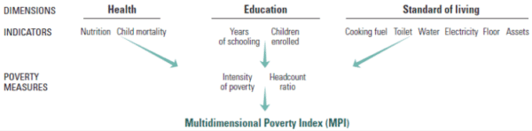
The Sen poverty index is a composite poverty measure, which combines the incidence and intensity of poverty risk with the distribution of income among those at risk of poverty. It is calculated by averaging the square of the poverty gap ratio.
Section 2-Review of Literature
In this section, a brief Review of the Literature is given. There are several studies in measuring global Poverty, but only a few latest ones are presented here. Onesme Nzasabaye, Senthil Kumar Jaya Prakash and Rama Prasad M.V (2024) conclude that “ we recommend that future researchers, while keeping an eye on Africa, livelihoods, gender inequality, and India, focus more on poverty alleviation, China, and sustainable development. Special attention also must focus on the household, remittance, land use, government, and IMF and find ways to improve their role in poverty alleviation strategies for sustainable development.” They also state that future researchers should focus on how the governments, the IMF, and the World Bank can fully contribute to the poverty alleviation process for sustainable development.
One of the conclusions of the World Bank (2024) Poverty report is that eradicating poverty and boosting shared prosperity on a liveable planet requires managing trade-offs. In this Report, it is stated that “Progress on the interlinked goals requires faster and inclusive growth and protecting people from extreme weather events. Enabling the poor to benefit more from economic growth involves better-functioning labour markets, investments in the productive capacity of people, and structural conditions that enable socioeconomic mobility so that everyone can use their productive capacity to their full extent. Protecting people from extreme weather events requires acting on two fronts: (a) lowering vulnerability by enhancing risk management and (b) preventing the escalation of future climate hazards by accelerating transformations to reduce the emissions intensiveness of growth.”
In their article on Programs, Opportunities, and Challenges in Poverty Reduction: A Systematic Review, Nyoman Ruja, Sumarmi, and Idris point out that these twenty-two authors have done work on these topics. Poverty alleviation programs (Poverty alleviation in urban areas, in rural areas, poverty alleviation programs through women’s empowerment, and determinants of programs implementation), opportunities and challenges (poverty alleviation opportunities and poverty alleviation challenges)
(Tom Baker et al. (2020); Kirk Vander Molen et al. (2020); Rui Jie Peng (2021); Huang et al. (2021); Pan et al. (2021); Leng Gen xiao et al. (2021); Huanguang et al. (2020); Z. Zou et al. (2021); Cheng xiao-yu et al. (2021); J. Tang et al. (2021); Rui and Ying (2021); Nugroho et al (2021); Gonzalo Gamboa et al. (2020); Jamal Appiah-Kubi (2021); Ko Ling Chan et al. (2021); E. Masset and J. Garcia (2021); Dolley et al (2020); J.O. Odhiambo et al (2020); Garcia and Cuartas (2020); Cunha et al. (2021); Minh Chau Lam (2020); Afriyie et al (2020);)
There are several other studies available, but not directly related to global poverty.
Section 3 -Data and Methodology
In this section, the emphasis is on data and methodology. The data and information related to poverty were collected from various sources and published official office records, mainly data from the Global Multidimensional Poverty Index 2023, undertaking global poverty: Data from high-impact action published by Oxford Poverty & Human Development Initiative (OPHI) and United Nations Development Program (UNDP), and development initiatives, economic poverty trends: Global, regional and national. Simple statistical tools such as averages and percentages were worked out for the purpose of interpreting of results. Only secondary data is used for the analysis.
Section 4- Comparative Analysis of Global Poverty Data
In this Section, the comparative analysis of Global data is presented with the help of four Tables.
Table 1- From this Table following observations can be made. There are three distinct poverty lines used in Table 1. Also, 2017 PPP (Purchasing Power Parity). Both the poverty line and 2017 PPP are used to account for inflation and to illustrate the global progress made in eliminating extreme poverty between 1990 and 2006. The purpose is to keep track of how many people are impoverished and what percentage of the world's population is impoverished at various income levels.
The line for $3.65 per day for moderate poverty denotes a higher threshold, which includes people in less severe poverty. In 1990, 3.0 billion people were living below this threshold, or 56% of the world's population, and by 2006, that figure had dropped to 2.8 billion, or 42% of the world's population. In absolute terms, between 1990 and 2006, the number of people living below this level increased from 3.6 billion (1990) to 4.1billion (2006). However, when one observes the proportion of people living below the poverty line, it has reduced from 69% in 1990 to 63% in 2006.

Table 1: Global Economic Poverty Trends: Global progress in the reduction of extreme poverty since 1990 to 2006
Year | Number of people living in poverty  (billians) Extreme Poverty ($2.15 2017 PPP) | Proportion of people living in poverty | Number of people living in poverty  (billions)  Extreme Poverty ($ 3.65 2017 PPP) | Proportion of people living in poverty line | Number of people living in poverty  (billions)  Extreme Poverty ($ 6.85 2017 PPP) | Proportion of people living in poverty line
1990 | 2.0 | 38% | 3.0 | 56% | 3.6 | 69%
1991 | 2.0 | 38% | 3.0 | 56% | 3.7 | 69%
1992 | 2.0 | 37% | 3.1 | 56% | 3.8 | 70%
1993 | 2.0 | 36% | 3.1 | 56% | 3.9 | 70%
1994 | 2.0 | 34% | 3.1 | 55% | 4.0 | 70%
1995 | 1.9 | 33% | 3.1 | 54% | 4.0 | 70%
1996 | 1.8 | 31% | 3.1 | 53% | 4.0 | 70%
1997 | 1.8 | 31% | 3.1 | 53% | 4.1 | 69%
1998 | 1.9 | 31% | 3.1 | 53% | 4.1 | 69%
1999 | 1.8 | 30% | 3.2 | 52% | 4.2 | 70%
2000 | 1.8 | 29% | 3.1 | 51% | 4.2 | 69%
2001 | 1.8 | 28% | 3.1 | 50% | 4.2 | 68%
2002 | 1.7 | 27% | 3.1 | 49% | 4.2 | 67%
2003 | 1.6 | 26% | 3.0 | 48% | 4.2 | 67%
2004 | 1.5 | 24% | 2.9 | 46% | 4.2 | 65%
2005 | 1.4 | 22% | 2.8 | 44% | 4.2 | 64%
2006 | 1.4 | 21% | 2.8 | 42% | 4.1 | 63%
Source: Development Initiatives based on World Bank PIP, Mahler et al. 2022, UN World Population Prospects and IMF World Economic Outlook, Forecasts begin in 2020. Author: Zach Christensen
Table 2: From the Table the following features are noted. This Table illustrates global trends in extreme poverty from 2007 to 2022. It analyses the percentage of the world's population that lives below three distinct poverty levels, which are expressed in terms of $2.15, $3.65, and $6.85 per day (in 2017 purchasing power parity, or PPP).
The most severe measure of poverty is Extreme Poverty ($2.15 2017 PPP). It is noted from the Table that the number of people living in extreme poverty has decreased from 1.3 billion in 2007 (20% of the world's population) to 0.7 billion in 2022 (9% of the population). This is a good achievement.
Moderate poverty group (3.65 2017 PPP) are those people who live on somewhat more than the extreme poverty limit but are nonetheless dealing with significant financial difficultiess. There is decline in moderate poverty since the number of persons in this group fell from 2.7 billion (41% of the world's population) in 2007 to 1.8 billion (23%), in 2022.
Further, those who fall into the near-poverty ($6.85 2017 PPP) group are barely over the extreme and moderate poverty lines. From 4.1 billion (61%) in 2007 to 3.7 billion (47%) in 2022, the number of people living in near-poverty declined, showing a continuous but slower decline than in the other categories.
Although the rate of improvement varies depending on the level of poverty, the data generally demonstrates consistent global success in eliminating poverty across all these thresholds. However, it is observed that a sizable fraction of the population still lives just over the poverty line, which poses constant difficulties for the advancement of the world economy.

Table 2: Global Economic Poverty Trends: Global progress in the reduction of extreme poverty since 2007 to 2022

Year | Number of people living in poverty  (billians) Extreme Poverty ($2.15 2017 PPP) | Proportion of people living in poverty | Number of people living in poverty  (billions)  Extreme Poverty ($ 3.65 2017 PPP) | Proportion of people living in poverty line | Number of people living in poverty  (billions)  Extreme Poverty ($ 6.85 2017 PPP) | Proportion of people living in poverty line
2007 | 1.3 | 20% | 2.7 | 41% | 4.1 | 61%
2008 | 1.3 | 19% | 2.7 | 40% | 4.1 | 60%
2009 | 1.2 | 18% | 2.6 | 39% | 4.1 | 59%
2010 | 1.1 | 16% | 2.5 | 36% | 4.0 | 58%
2011 | 1.0 | 14% | 2.4 | 34% | 3.9 | 56%
2012 | 1.0 | 13% | 2.3 | 33% | 3.9 | 55%
2013 | 0.9 | 12% | 2.2 | 31% | 3.8 | 53%
2014 | 0.8 | 11% | 2.2 | 30% | 3.8 | 52%
2015 | 0.8 | 11% | 2.1 | 29% | 3.7 | 51%
2016 | 0.8 | 11% | 2.1 | 28% | 3.7 | 50%
2017 | 0.7 | 10% | 2.0 | 27% | 3.7 | 49%
2018 | 0.7 | 9% | 1.9 | 25% | 3.6 | 47%
2019 | 0.7 | 9% | 1.8 | 23% | 3.6 | 47%
2020 | 0.7 | 9% | 2.0 | 25% | 3.8 | 48%
2021 | 0.7 | 9% | 1.9 | 24% | 3.7 | 47%
2022 | 0.7 | 9% | 1.8 | 23% | 3.7 | 47%
Source: Development Initiatives based on World Bank PIP, Mahler et al. 2022, UN World Population Prospects and IMF World Economic Outlook, Forecasts begin in 2020. Author: Zach Christensen
Multidimensional Poverty Index: developing countries
Table 3Based on surveys conducted between 2017 and 2022, the Multidimensional Poverty Index (MPI) statistics for developing nations is shown in this Table. Instead of focusing only on money, it is interesting to observe that the MPI considers several variables, including living standards, health, and education, when calculating poverty. The columns represent the following variables:
Country: Provides the name of the nation.The value of the Multidimensional Poverty Index (MPI), which represents the nation's overall poverty level, is displayed.
Year and Survey: The type of survey (D for demographic, M for multi-dimensional, and N for national) and the year or years in which the data was gathered.
Population in Multidimensional Poverty (%): Theproportion of the population that is living in multidimensional poverty, which is characterized by a lack of access to essential services in areas such as living standards, health care, and education.
Severe Multidimensional Poverty Population (%): the proportion of the population that is severely impoverished in several ways, usually signifying a greater level of deprivation.
Population Vulnerable to Multidimensional Poverty (%). This indicates The percentage of the population that could experience multidimensional poverty in the event of a minor social or economic setback.
SDG 11 Sustainable cities and communities: The sustainable development of cities take part a significant role in the development of the nations as these are opportunities for people to prosper economically and socially.
SDG 12 Sustainable consumption and production:.This goal is about promoting efficient use of natural resources, Energy efficiency and sustainable infrastructure.
Population Below Monetary Poverty Line (%): This indicates the proportion of the population that lives below specific poverty levels, both according to the international threshold of PPP $2.15/day (purchasing power parity) and the national poverty line.
From the Table it may be concluded that the prevalence of multidimensional poverty in different developing nations, highlighting the number of individuals who experience numerous forms of deprivation and the communities' potential susceptibility to poverty. While some nations, like Albania, Costa Rica, and Palestine, exhibit far lower levels of multidimensional poverty, others, like Burundi, Chad, and Madagascar, have extremely high MPI values, suggesting widespread and severe poverty.
Table 3: Multidimensional Poverty Index: Developing Countries (Estimates based on surveys for 2017-2022)
S.No | Country | Multidimensional Poverty Index | Population in multidimensional poverty |  | SDG 12 | SDG 11
 |  | Year and survey | Population in severe multidimensional poverty | Population vulnerable to multidimensional poverty | Population living below monetary poverty line (%)
 |  | 2011-2022 | % | % | National poverty line | PPP $2.15 a day
 | Estimates based on surveys for 2017-2022
1 | Albania | 2017/2018 D | 0.1 | 5.0 | 21.8 | 0.0
2 | Algeria | 2018/2019 M | 0.2 | 3.6 | 5.5 | 0.5
3 | Argentina | 2019/2020 M | 0.0 | 1.6 | 42.0 | 1.0
4 | Bangladesh | 2019 M | 6.5 | 18.2 | 24.3 | 13.5
5 | Benin | 2017/2019 D | 40.9 | 14.7 | 38.5 | 19.9
6 | Burundi | 2016/2017 D | 46.1 | 15.8 | 64.9 | 65.1
7 | Cambodia | 2021/2022 D | 4.1 | 20.5 | 17.7 | -
8 | Cameroon | 2018 D | 24.6 | 17.6 | 37.5 | 25.7
9 | Central African Republic | 2018/2019 M | 55.8 | 12.9 | - | -
10 | Chad | 2019 M | 64.5 | 10.7 | 42.3 | 30.9
11 | Congo (Democratic Republic of the ) | 2017/2018 M | 36.8 | 17.4 | 63.9 | 69.7
12 | Costa Rica | 2018 M | 0.0 | 2.4 | 30.0 | 1.2
13 | Cuba | 2019 M | 0.1 | 2.7 | - | -
14 | Dominican Republic | 2019 M | 0.2 | 4.8 | 21.0 | 0.9
15 | Ecuador | 2018 N | 0.1 | 5.9 | 33.0 | 3.6
16 | Ethiopia | 2019 D | 41.9 | 18.4 | 23.5 | 27.0
17 | Fiji | 2021 M | 0.2 | 7.4 | 24.1 | 1.3
18 | Gambia | 2019/2020 | 17.3 | 28.0 | 48.6 | 17.2
19 | Georgia | 2018 M | 0.0 | 2.1 | 21.3 | 5.5
20 | Ghana | 2017/2018 M | 8.4 | 20.1 | 23.4 | 25.2
21 | Guiea | 2018 D | 43.5 | 16.4 | 43.7 | 13.8
22 | Guinea- Bjssau | 2018/2019 M | 35.9 | 20.0 | 47.7 | 21.7
23 | Guyana | 2019/2020 M | 0.2 | 6.5 | - | -
24 | Haiti | 2016/2017 D | 18.5 | 21.8 | 58.5 | 29.2
25 | Honduras | 2019 M | 3.0 | 14.8 | 48.0 | 12.7
26 | India | 2019/2021 D | 4.2 | 18.7 | 21.9 | 10.0
27 | Indonesia | 2017 D | 0.4 | 4.7 | 9.8 | 3.5
28 | Iraq | 2018 M | 1.3 | 5.2 | 18.9 | 0.1
29 | Jamaica | 2018 N | 0.2k | 5.0 | 19.9 | -
30 | Jordan | 2017/2018 D | 0.0 | 0.7 | 15.7 | -
31 | Kiribati | 2018/2019 M | 3.5 | 30.2 | 21.9 | 1.7
32 | Kyrgyzstan | 2018 M | 0.0 | 5.2 | 25.3 | 1.3
33 | Leo People’s Democratic Republic | 2017 M | 9.6 | 21.2 | 18.3 | 7.1
34 | Leosotho | 2018 m | 5.0h | 28.6 | 49.7 | 32.4
35 | Liberia | 2019/2020 D | 24.9 | 23.3 | 50.9 | 27.6
36 | Madagascar | 2021 D | 45.8 | 15.4 | 70.7 | 80.7
37 | Malawi | 2019/2020 M | 17.5 | 27.5 | 50.7 | 70.1
38 | Maldives | 2016/2017 D | 0.0 | 4.8 | 5.4 | 0.0
39 | Mali | 2018 D | 44.7 | 15.3 | 44.6 | 14.8
40 | Mauritania | 2019/2021 D | 38.0 | 12.3 | 31.8 | 6.5
41 | Mexico | 2021 M | 0.8lm | 3.5 | 43.9 | 3.1
42 | Mongolia | 2018 M | 0.8n | 15.5 | 27.8 | 0.7
43 | Montenegro | 2018 M | 0.1 | 2.9 | 22.6 | 2.8
44 | Morocco | 2017/2018 P | 1.4 | 10.9 | 4.8 | 1.4
45 | Mozambique | 2019/2020 N | 43.0kd | 13.9 | 46.1 | 64.6
46 | Nepal | 2019 M | 4.9 | 17.8 | - | -
47 | Nigeria | 2021 M | 18.1q | 16.6 | 40.1 | 30.9
48 | North Macedonia | 2018/2019 M | 0.1 | 2.2 | 21.8 | 2.7
49 | Pakisthan | 2017/2018 D | 21.5 | 12.9 | 21.9 | 4.9
50 | Palestine, State of | 2019/2020 M | 0.0 | 1.3 | 29.2 | 0.5
51 | Papua New Guinea | 2016/2018 D | 25.8l | 25.3 | - | -
52 | Peru | 2021 N | 0.9 | 10.4 | 30.1 | 2.9
53 | Phillippines | 2017 D | 0.3l | 7.3 | 16.7 | 3.0
54 | Rwanda | 2019/2020 D | 19.7 | 22.7 | 38.2 | 52.0
55 | Samoa | 2019/2020 M | 0.5 | 12.9 | 20.3 | 1.2
56 | Sao Tome and Principe | 2019 M | 2.1 | 17.0 | 66.7 | 15.6
57 | Senegal | 2019 D | 27.7 | 18.2 | 46.7 | 9.3
58 | Serbia | 2019 M | 0.0 | 2.1 | 21.7 | 1.6
59 | Seychelles | 2019 N | 0.0 | 0.4 | 25.3 | 0.5
60 | Sierra leone | 2019 D | 28.0 | 21.3 | 56.8 | 36.1
61 | Suriname | 2018 M | 0.4 | 4.0 | - | -
62 | Tajikistan | 2017 D | 0.7 | 20.1 | 26.3 | 6.1
63 | Thailand | 2019 M | 0.0 | 6.1 | 6.8 | 0.0
64 | Togo | 2017 M | 15.2 | 23.8 | 45.5 | 28.1
65 | Tonga | 2019 M | 0.0 | 6.4 | - | 1.8
66 | Tunisia | 2018 M | 0.1 | 2.4 | 15.2 | 0.1
67 | Turkmenistan | 2019 M | 0.0h | 0.3 | - | -
68 | Tuvalu | 2019/2020 M | 0.0 | 12.2 | - | -
69 | Uzbekistan | 2021/2022 M | 0.0u | 0.2 | 14.1 | -
70 | Viet Nam | 2020/2021 M | 0.4 | 3.5 | 6.7 | 0.7
71 | Zambia | 2018 D | 21.0 | 23.9 | 54.4 | 61.4
72 | Zimbabwe | 2019 M | 6.8 | 26.3 | 38.3 | 39.8

Source: Global Multidimensional Poverty Index 2023 Unstacking global poverty: Data for high impact action, Statistical tables, developing countries, pp.20-21.
Development Initiatives based on World Bank PIP, Mahler et al. 2022, UN World Population Prospects and IMF World Economic Outlook, Forecasts begin in 2020. Author: Zach Christensen
Table-4
Based on surveys done between 2011 and 2016, the Multidimensional Poverty Index (MPI) for a number of developing nations are given in this Table.. MPI is a method for evaluating poverty that considers factors other than income, like living conditions, healthcare, and educational opportunities.Essential Components of the Table-4:
Country/Region: The listed countries and regions, which include both individual countries and more expansive regional groupings like Sub-Saharan Africa, East Asia and the Pacific, etc., are all components of the developing globe.Survey Period: The year or years that the data was collected are shown, such as 2015–2016 for Afghanistan and other nations.
MPI Components: Each nation or region's multiple multidimensional poverty indicators are represented by the numbers in the columns:
(column 3) shows the proportion of the population that is deemed to be multidimensionally poor according to several criteria, including standard of living, health, and education.
(column 4).The percentage of the population living in extreme multidimensional poverty is indicated by the second number
(column 5) indicates the proportion of the population that is multidimensionally at risk of poverty.
(column 6).The specific indicator for multidimensional poverty in certain countries, which may not be available for all is given in this column
From Table 4 it may be noted that when one looks at the data for Countries versus Regions, the regional aggregates displayed in the bottom section give a general idea of poverty in different geographical areas: Arab States: Having an MPI that is comparatively low.Low rates of poverty are also seen throughout East Asia and the Pacific.Multidimensional poverty is similarly low across Europe and Central Asia.In terms of access to essential services, poverty rates are higher in Latin America and the Caribbean.South Asia: Considerable vulnerability and moderate poverty.The highest rates of multidimensional poverty are seen in Sub-Saharan Africa.
In brief,this table provides a picture of multidimensional poverty across developing nations and regions. While some nations, especially those in Sub-Saharan Africa, have greater rates of severe poverty, others, like Kazakhstan or Armenia, exhibit lower levels of multidimensional poverty.
Table 4: Multidimensional Poverty Index: Developing Countries (Estimates based on surveys for 2011-16)
 | Estimates based on surveys for 2011-2016
S.No | Country | Multidimensional Poverty Index | Population in multidimensional poverty | SDG 12 | SDG 11
 |  | Year and survey | Population in severe multidimensional poverty  Column 3 | Population vulnerable to multidimensional poverty  Column4 | Population living below monetary poverty line (%)  Column5 | Column6
 |  | 2011-2022 | % | % | National poverty line | PPP $2.15 a day
1 | Afghanistan | 2015/2016D | 24.9 | 18.1 | 54.5 | -
2 | Angola | 2015/2016 D | 32.5 | 15.5 | 32.3 | 31.1
3 | Armenia | 2015/2016 D | 0.0 | 2.8 | 26.5 | 0.5
4 | Barbados | 2012 M | 0.0 | 0.5 | - | -
5 | Belize | 2015/2016 M | 0.6 | 8.4 | - | -
6 | Bolivia ( Plurinational State of ) | 2016 M | 1.9 | 12.1 | 36.4 | 2.0
7 | Bosnia and Herzegovina | 2011/2012 M | 0.1 | 4.1 | 16.9 | 0.1
8 | Botswana | 2015/2016 M | 3.5 | 19.7 | - | 15.4
9 | Brazil | 2015 N | 0.9 | 6.2 | - | 5.8
10 | China | 2014 N | 0.3 | 17.4 | 0.0 | 0.1
11 | Colombia | 2015/2016 D | 0.8 | 6.2 | 39.3 | 6.6
12 | Comoros | 2012 D | 16.1 | 22.3 | 42.4 | 18.6
13 | Congo | 2014/2015 M | 9.4 | 21.3 | 40.9 | 35.4
14 | Cote d’ lvoire | 2016 M | 24.5 | 17.6 | 39.5 | 11.4
15 | Egypt | 2014 D | 0.6 | 6.1 | 32.5 | 1.5
16 | El Salvador | 2014 M | 1.7 | 9.9 | 26.2 | 3.6
17 | Eswatini (Kingdom of ) | 2014 M | 4.4 | 20.9 | 58.9 | 36.1
18 | Gabon | 2012 D | 5.1 | 18.4 | 33.4 | 2.5
19 | Guatemala | 2014/2015 D | 11.2 | 21.1 | 59.3 | 9.5
20 | Kazakhstan | 2015 M | 0.0 | 1.8 | 5.2 | 0.0
21 | Kenya | 2014 D | 12.4 | 35.8 | 36.1 | 29.4
22 | Libya | 2014 P | 0.1 | 11.4 | - | -
23 | Moldova (Republic of ) | 2012 M | 0.1 | 3.7 | 24.5 | 0.0
24 | Myanmar | 2015/2016 D | 13.8 | 21.9 | 24.8 | 2.0
25 | Namibia | 2013 D | 13.1 | 19.2 | 17.4 | 15.6
26 | Nicaragua | 2011/2012 D | 5.6 | 13.4 | 24.9 | 3.9
27 | Niger | 2012 D | 76.3 | 4.9 | 40.8 | 50.6
28 | Praguay | 2016 M | 1.0 | 7.2 | 26.9 | 0.7
29 | Saint Lucia | 2012 M | 0.0 | 1.6 | 25.0 | 5.1
30 | South Africa | 2016 D | 0.9 | 12.2 | 55.5 | 20.5
31 | Sri Lanka | 2016 N | 0.3 | 14.3 | 4.1 | 1.0
32 | Sudan | 2014 M | 30.9 | 17.7 | - | 15.3
33 | Tanzania (United Republic of ) | 2015/2016 D | 27.5 | 23.4 | 26.4 | 44.9
34 | Timor- Leste | 2016 D | 17.4 | 26.8 | 41.8 | 24.4
35 | Trinidad and Tobago | 2011 M | 0.1 | 3.7 | - | -
36 | Uganda | 2016 D | 25.7 | 23.6 | 20.3 | 42.2
37 | Ukraine | 2012 M | 0.0 | 0.4 | 1.6 | 0.0
38 | Yemen | 2013 D | 24.3 | 22.3 | 48.6 | 19.8
39 | Developing Countries | - | 7.9 | 14.8 | 20.1 | 10.5
40 | Regions
41 | Arab States | - | 6.9 | 9.0 | 23.4 | 4.7
42 | East Asia and the Pacific | - | 0.9 | 14.4 | 3.8 | 0.8
43 | Europe and Central Asia | - | 0.1 | 2.5 | 12.2 | 0.7
44 | Latin America and the Caribbean | - | 1.5 | 6.5 | 37.9 | 4.9
45 | South Asia | - | 6.9 | 17.9 | 22.6 | 9.2
46 | Sub- Saharan Africa | - | 27.9 | 18.6 | 41.1 | 37.4

Source: Global Multidimensional Poverty Index 2023 Unstacking global poverty: Data for high impact action, Statistical tables, developing countries, pp.20.
Development Initiatives based on World Bank PIP, Mahler et al. 2022, UN World Population Prospects and IMF World Economic Outlook, Forecasts begin in 2020. Author: Zach Christensen
Conclusions
This is a simple pilot study to examine the concept of global poverty and seek an overall idea of its existence in different countries and compare between countries and regions. Some of the main findings are that it depicts a noteworthy decrease in the percentage and population living below the lowest poverty level ($2.15 per day), indicating substantial global success in decreasing severe poverty throughout the 16-year period. Even though fewer people are living in extreme poverty, the statistics for the higher thresholds indicate that poverty is nonetheless pervasive.

- There is no single definition of Poverty. It is multidimensional and has many aspects.
- The studies related to Poverty are abundant in the literature and authors have used different sets of data and variables to measure poverty.
- It is possible to do research on this topic in future both on primary and secondary data.
- From the analysis of data used in this paper the main conclusion is that global poverty has declined over the study period.
References
Chen, J., Catalano, T. J., & Williams, P. (2024). What is poverty? Meaning, causes, and how to measure.
Christensen, Z. (2020). Development initiatives based on World Bank PIP. http://www.worldbank.org/
Global MPI 2023. (n.d.). https://ophi.org.uk/global-mpi/2023
Global Multidimensional Poverty Index. (2023). Unstacking global poverty: Data for high impact action, Statistical Tables Developing Countries, 20-21.
Gweshengwe, B., & Hassan, N. H. (2020). Defining the characteristics of poverty and their implications for poverty analysis. Cogent Social Sciences, 6(1). https://doi.org/10.1080/23311886.2020.1768669
Nzasabayezu, O., Kumar Jaya Prakash, S., & Prasad, R. M.V. (2024). A study of poverty alleviation strategies for sustainable development: A scientometric analysis, 10 (13). https://doi.org/10.1016/j.heliyon.2024.e33469
Ruja Sumarmi, N., & Idris. (2024). Programs, opportunities, and challenges in poverty reduction: A systematic review. SAGE Open, 14(2). https://doi.org/1177/21582440241256242
What is Poverty, Types of Poverty, Poverty Line Explained. (2025).https://papertyari.com/general-awareness/economics/poverty-types-poverty-line-explained/

Essential Early Childhood Educator Dispositions: The Love & Care for Children

Dr. Teresa LeSage Clements, UH-Victoria, Dr. Barba Aldis Patton, UH-Victoria, & Dr. Lynda Cavazos, UT San Antonio

Turnover is high in childcare learning centers, although some early childhood educators stay on the job despite low wages and a lack of professional respect. The focus of this study was on childcare educators' job satisfaction and the motivation of early childhood educators. Quality education and childcare should be everyone’s top priority since children who receive high-quality education and nurturing care will have an advantage over young children without it. (Barnett 1995; Da Ros-Voseles & Fowler-Haughey 2007). Providing high-quality early childcare is a no-brainer, but still, some children do not have access and are already one to two years behind when they begin kindergarten. It is of utmost importance that childcare teachers with the right disposition stay on the job because the children need them emotionally and academically for a better chance of success in life. Many children in care centers have more teachers and their parents. Childcare teachers may be the most important people in some children 's lives. This work captured the voices of twelve early childhood educators, who overwhelmingly communicate that they love and care for the children, which is why they stay on the job (Cavazos et al., 2024). There is more in this study beyond the scope of this paper, but this portion of the research was essential to expand and communicate to all education stakeholders quickly. We all know the state of education. Test results are dismal. Students continue to decline in reading and math, even when billions of dollars are pumped in. Let us start with our littlest children and give them some help early, so they are not one to two years behind in school when entering kindergarten.

Keywords: early childhood, professional development, stakeholders, childcare, teacher education, mindset shifts, effective teacher dispositions

Purpose
The study aimed to explore childcare teachers’ perceptions of job satisfaction and retention at early childhood centers in a southwest urban city in the United States. The primary question guiding this study was the following:
- What motivational factors do childcare teachers perceive have contributed to their job satisfaction and retention?
Self-determination theory was used to answer this question. The theory incorporates autonomy, competence, and relatedness (Deci & Ryan, 1985). The theory describes how interactions between early childhood teachers and the system within their work influence motivation in their teaching and their authentic well-being as educators. In the self-determination theory, the “environment is autonomous, supportive, and controlling and will influence the degree of intrinsic motivation that an individual feels toward a given task” (Deci & Ryan, 1985).
Early Childcare Teacher
The early childcare teacher is primarily female and white (Paschall et al., 2020; Kim & Reifel 2010), although the trend is fluid due to the US demographics changing. Teacher turnover is high, up to 50 % for first-year teachers (LeSage Clements et al., 2013). Teacher retention and attrition are now harder to measure since many schools have teachers sign two-year or more contracts. Sadly, new, inexperienced teachers leave the profession or search for a school with better working conditions. Then, year after year, children receive instruction from inexperienced teachers, falling behind several grade levels over the years (LeSage-Clements & Patton, 2018). The childcare teacher is one of a child’s most important people outside their family. When a baby or young child loses a teacher, they grieve the loss of a caretaker. It is like losing a parent to a child (Cavazos et al., 2024).
There are obstacles to hiring high-quality teachers. The wages are low for the equivalent skill level. The childcare educators in this study had an associate's and/or college degree (Cavazos et al., 2024). The teachers work long hours, are not respected as professionals, and receive few or no benefits.
- Why do they stay on the Job? What is their motivation?
The following are several examples of the teachers loving and caring for children. The theme of love and caring dispositions emerged repeatedly. All the quotes below were cited from Cavazos et al., 2024.
- “The love I get from the children and their smiles and their hugs that is what keeps me going. I like to help children learn new concepts and encourage them to achieve their goals. The love I get from the children and that they feel the love … and they smile a lot.”
- “I had been out of the classroom for a week to help with leadership duties in the center’s office. When I got back in the classroom, they all ran to me, and I felt so much love for them.”
- “Seeing their little faces. They get all excited and happy. It’s all about the children. I love teaching them, and I love being there for them.”
- “I am good here. You have to have all of those qualities of motivation, patience, and love for the children and for who they are. You have to be serious to really take on this profession.”
- Just knowing that I made an imprint even if it’s just a small imprint then I’ve done my job. I’m just very humbled that I have a small part in their life and it’s a great feeling.”
- “It’s just that rewarding feeling that you get when the children feel close to you that you just feel like you can go home and that you did something good for them. We really don’t know how their life is away from here, so we give them that little bit of three to four hours of learning and bonding, and that is what keeps it motivating.”
- “I am so lucky to be in this profession. If you can go to work every day and get hugs and smiles from little ones, then that is job satisfaction.”
- “I love seeing their faces when they hear the birds or when I am blowing bubbles. They communicate by smiling, laughing, and trying to reach for the bubbles.”
- “I am very excited to come to work! You have these little blessings to hold, and that’s job satisfaction, increasing their little minds. This makes me happy, and they are happy.”
- I love what I do. I love being here. I have been here so long, and it’s like my second home. I don’t know how I would be somewhere else. I’m very satisfied with being here. I love my responsibility to be with the children. It’s all satisfying. It’s my job satisfaction.”
- “I like doing what I do. If I didn’t, I wouldn’t be in this field. I like it. I love my job; I love children. It’s something I always wanted to do, but most importantly, it takes patience, and I’m going to keep on doing it because I like what I am doing.”
- “The children get so excited when I tell them it is art time, and they go Yeah! I love for them to do art, and it’s important for their development. They love for me to hang up their artwork. There are so many loving moments in being with the children; everyone has something unique and special about them.”
- “They are the future. Teaching is all that I have ever known. I have only been in this type of setting.”
- “I just love being with them, hearing their stories; I love helping them and teaching them.”
Conclusions & Recommendations
The most important attributes of a childhood teacher's job satisfaction are the teacher’s disposition to love, care for, and nurture young children. All stakeholders preparing and hiring early childhood educators must select teachers with loving & caring dispositions. If you want a satisfied & motivated teacher, hire one who loves and cares for children. Children in high-quality preschools have greater academic achievement and are more likely to graduate from high school and be successful in trade and university institutions. Early childhood educators prepare young children for the rest of their education. Education stakeholders must note that the teacher’s disposition of loving and caring for children is essential for a successful early childhood educator and the children under their care.

References
Cavazos, L. & LeSage-Clements, T. & Patton, B. (2024). The pillar of child educator job satisfaction: The love & care for children. National Social Science Journal Volume 62 2 512.17.24.
Barnett, W.S. (1995). Long-term effects of early childhood programs on cognitive
and school outcomes. The Future of Children 5(3), 25-50.

Da Ros-Voseles, D., & Fowler-Haughey, S. (2007). The role of dispositions in the
education of future teachers. Young Children 62(5), 90–98.

Deci, E. L., & Ryan, R. M. (1985). Intrinsic motivation and self-determination in
human behavior. Plenum Press.

Katz, L.G. (1993). Dispositions: Definitions and implications for early childhood practices. ERIC Clearinghouse on Elementary and Early Childhood Education. http://ceep.crc.uiuc.edu/eecearchive/books/disposit.html

Kim, M. & Reifel, S. (2010). Childcare teaching as women’s work: Reflections on
Experiences. Journal of Research in Childhood Education, 24, 229-247.
LeSage-Clements, T. & Patton, B. A. (2018). Are LOW socio-economic students being SET -UP for failure? National Social Science Journal (NSSA). V 51 1 p 37.
LeSage Clements, T., Patton, B., Prince. D., & Carlson, P. (2013). Billions of dollars wasted: New teacher preparation models needed. Natural Social Science Journal http://www.nssa.us/journals/pdf/NSS_Journal_41_1.pdf p 64.

Paschall, K., Madill, R., & Halle, T. (2020). Professional characteristics of the early care and education workforce: Descriptions by race, ethnicity, languages spoken, and nativity status. OPRE Report #2020-107. Washington, DC: Office of Planning, Research, and Evaluation, Administration for Children and Families, U.S. Department of Health and Human Services.

Anomalies make Math Skills difficult for Students

Barba Aldis Patton, University of Houston-Victoria &Teresa LeSage Clements, University of Houston-Victoria

Students are often taught hard rules that expire as they advance to the next grade level. Some of the rules are… if you multiply, you will always get a larger number …. If you divide, you will always get a smaller number. Surely, there are hard rules and anomalies in other content areas that lead to confusion in the student’s learning cycle. Some will make you say, “Yes, that is true,” while others will make you think, “I did not think about it.” Some of the hard rules and anomalies can be resolved by redirection, but everyone must be on the ‘correction train’.
Keywords: mathematics, student experiences, educational content challenges, student-learning cycle

Anomalies in math are often difficult for non-math people to understand; therefore, the following example might help. The act of drinking water or other liquids, which is often called a ‘drink’, is common and necessary for all living things. Now put yourself in the math classroom where the problem-solving lingo is asking students to solve situations with mostly words; it can and does get very complicated. Just think a moment, it might be called a beverage, thirst-quencher, pick-me-up, juice, soda, swill, pop, cocktail, beer, nip, tipple, snifter, pint, half, mouthful, taste, gulp, swallow, swig, slurp, sip, glug, draught, draft, imbibe, down, (sorry some of the words are more on the adult level, but just stating the many options). Often, if a student moves to one of the southern states and desires a carbonated drink, that student will ask for ‘pop’. The southern classroom peers will be very puzzled. These southern classroom peers will think it is odd that this new peer is asking to be ‘hit’. Pop to the southern peer usually means something is being hit and not usually a good act. Although this is not math, it helps to illustrate how confusion of words can hinder students’ learning process in math as well as other disciplines. Since the students are not able to use their first language, they will often just put up on the numbers. They may be in symbol form as well as written, such as 15 and fifteen. This is great if it is a straightforward situation but what if something is tossed in such as a highway identification. As an example:
Bill’s father just purchased an XT8. The family is going on a trip from their hometown to see the Grand Canyon by traveling on Route 66. The navigator in the car said it was 526 miles. If Bill’s father drives an average of 62 mph, how many hours and minutes will the family be in the car before arriving at their destination? [8 hr. 29 min] How long will the family be in the car when they return home? [16 hr. 58 min] How many miles will the family travel on their vacation? [1052 miles] (Patton, 2025)
Many students, especially those lacking a good command of the English language, will have difficulties with the above example. There are so many ways and answers the students will have, it is scary as these students hold the future of our world in their hands. In the problem, there are the numbers 8,66,526, and 62 listed, and the words average, hours, minutes, how many, and how long. Many students will add 8+66+526+62 [get 662], and the very sad thing is that the student will believe the answer is correct. Many students only know how to pick out the numbers. (Patton, 2025). Words with most likely not in the students’ vocabulary are purchases; XT8, trip, hometown, Grand Canyon, traveling, route 66, navigator, average, arriving, destination, long, and return. In addition, if the student is from a destination using military time, 24 on the clock rather than 12, more confusion will exist.
Once, it was common to hear that math has its own universal language. That is a true statement when working with operations with basic facts such as addition, subtraction, etc., but it is not true when working with words or real-life problems where language plays a big role. Most English-speaking educated people realize that when the word ‘add’ is used in math, it means putting things together. However, the thesaurus has many additional words such as enhance, complement, improve, augment, increase, supplement, swell, enlarge, intensify, insert, adjoin, append, affix, attach, and even more. Needless to say, it is no wonder the students and even their parents are mixed up.
In conclusion, some of the hard rules students are taught in lower grades that need to be addressed will be addressed in future writing. The anomalies in the language of math are endless, and more study is being done.
References
Bernardo, A. B. (2001): Asymmetric activation of number codes in bilinguals: Further evidence for the encoding complex model of number processing. Memory & Cognition, 29 (7), 968–976.
Frenck-Mestre, C., & Vaid, J. (1993): Activation of number facts in bilinguals. Memory & Cognition, 21 (6), 809–818.
Martiniello, M. (2009). Linguistic complexity, schematic representations, and differential item functioning for English language learners in math tests. Educational Assessment, 14,160–179.
Patton, B. (2020) CUIN 4324 Syllabus. University of Houston-Victoria.,
Shaftek, J., Belton-Kocher, E., Glasnapp, D., & Poggio, J. (2006). The impact of language characteristics in mathematics test items on the performance of English Language Learners and students with disabilities. Educational Assessment, 11(2), 105–126.

Understanding Why In 1888 and In 1892: The Incumbent President Did Not Win The Election

Darrial Reynolds
South Texas College

Abstract

The purpose of this paper is to increase the understanding of why in the 1888 election and the 1892 election that the incumbent president did not win the election. Firstly, this paper examines how the eight Proclamations for the Suspension of Tariffs ordered by President Grover Cleveland from 1885 to 1888 helped him lose the 1888 presidential election. Secondly, this paper examines how the Tariff of 1890 helped President Benjamin Harrison lose the 1892 presidential election. Lastly, this paper concludes with an analysis of how the tariff policies of Grover Cleveland and Benjamin Harrison impacted their presidential legacies.

Key Words: Incumbent, Tariff, Proclamation, Public Opinion, Consumers, Farmers, Businessmen, and Presidential Election.

Introduction

The purpose of this paper is to increase the understanding of why in the 1888 election and the 1892 election that the incumbent president did not win the election. Firstly, this paper examines how the eight Proclamations for the Suspension of Tariffs ordered by President Grover Cleveland from 1885 to 1888 helped him lose the 1888 presidential election. President Cleveland ordered eight proclamations from 1885 to 1888 for the suspension of tariffs because he thought that the 47.5% average tariff rate on dutiable imports was too high. The eight proclamations decreased the average tariff rates on dutiable imports from 47.5% to 45%, thus lowering the prices that consumer paid for products from select nations.

Secondly, this paper examines how the Tariff of 1890 helped President Benjamin Harrison lose the 1892 presidential election. President Harrison signed the Tariff of 1890 into law because he thought that the 45% average tariff rate on dutiable imports was too low. The Tariff Act of 1890 increased the average tariff rates on dutiable imports from 45% to 50% to protect the businesses of the United States. Lastly, this paper concludes with an analysis of how the tariff policies of Grover Cleveland and Benjamin Harrison impacted their presidential legacies. Cleveland and Harrison get credit for being the 4th and 5th incumbent presidents to try and fail to win re-election.

President Grover Cleveland (1885–1889)

Grover Cleveland became the 22nd President of the United States on March 4, 1885 after winning the 1884 Presidential Election. Three important bills that he signed into law were the Interstate Commerce Act of 1887, the Indian General Allotment Act of 1887, and the Enabling Act of 1889. Essentially, the Interstate Commerce Act of 1887 created the Interstate Commerce Commission (ICC) to regulate the monopolistic practices of the railroad industry. Essentially, the Indian General Allotment Act of 1887 gave the president the power to take land from Native Americans because it allowed the president to allot the land within the reservations to individual Native Americans and to give all surplus land back to the public domain. Essentially, the Enabling Act of 1889 allowed North Dakota (39th state), South Dakota (40th state), Montana (41st state), and Washington (42nd state) to become states.
According to the article, Presidential Proclamations from 1789 to the Present (2024), President Cleveland ordered eight proclamations from 1885 to 1888 for the suspension of tariffs because he thought that the 47.5% average tariff rate on dutiable imports was too high. The eight proclamations decreased the average tariff rates on dutiable imports from 47.5% to 45%, thus lowering the prices that consumer paid for products from select nations. Following is a complete list of the eight proclamations for the suspension of tariffs on vessels arriving in the United States from select nations.
- Proclamation 267 (April 07, 1885) – Suspension of Tonnage Duties on Vessels Arriving From Trinidad, British West Indies
- The collection of the tonnage duty of 3 cents per ton was suspended.
- Proclamation 272 (September 09, 1885) – Suspension of Tonnage Duties on Vessels Arriving From Boca del Toro, United States of Colombia
- The collection of the tonnage duty of 3 cents per ton was suspended.
- Proclamation 276 (October 13, 1886) – Suspension of Import and Tonnage Duties on Goods From Cuba and Puerto Rico Entering the U.S. Under Spanish Flag
- Suspended the collection of import taxes and the tonnage duty of 3 cents per ton.
- Proclamation 277 (October 27, 1886) – Suspension of Import and Tonnage Duties on Spanish Vessels From Cuba and Puerto Rico
- Suspended the collection of import taxes and the tonnage duty of 3 cents per ton.
- Proclamation 279 (April 22, 1887) – Suspending Tonnage and Lighthouse Duties on Vessels From the Netherlands and Dutch West Indies
- Suspended lighthouse duties and tonnage duties of 6–30 cents per ton.
- Proclamation 280 (September 21, 1887) – Suspending Discriminating Tonnage and Import Duties on Spanish Vessels
- Suspended the collection of all import taxes and tonnage duties.
- Proclamation 283 (January 26, 1888) – Suspending Tonnage and Lighthouse Duties on German Vessels
- Suspended lighthouse duties and tonnage duties of 6–30 cents per ton.
- Proclamation 284 (April 16, 1888) – Suspending Tonnage Duties on Vessels From the Island of Guadeloupe
- Suspended lighthouse duties and tonnage duties of 6–30 cents per ton.

Impact of the 8 Proclamations on Public Opinion
According to the article, Grover Cleveland (2025), a majority of the people in the southern states and the western states wanted lower tariffs and the majority of the people in the northern states and the eastern states wanted higher tariffs. The eight proclamations from 1885 to 1888 ordered by President Grover Cleveland for the suspension of import tariffs lowered the average tariff rates on dutiable imports from 47.5% to 45%, thus lowering the price that consumers were required to pay for some private goods. The support and opposition for the eight proclamations from 1885 to 1888 ordered by President Grover Cleveland for the suspension of import duties can be broken down in the following fashion.
- Most of the consumers wanted lower tariffs because they wanted to buy cheap products from industries located in the United States and/or foreign nations.
- Most of the consumers did not want to pay more for basic goods and products.
- Most of the consumers were Democrats.
- Most of the farmers in the southern and western states wanted lower tariffs because they were selling their corn, wheat, and cotton at lower prices in foreign nations.
- Most of the farmers did not want to raise prices in a fashion that would reduce demand for their products in foreign nations.
- Most of the farmers were Democrats.
- Most of the businessmen in the northern and eastern states wanted higher tariffs because their products needed protection from the lower priced foreign products.
- Most of the businessmen did not want to lower prices in a fashion that would increase demand.
- Most of the businessmen were Republicans.

Impact of the 8 Proclamations on the 1888 Election Results
According to the article, The Presidential Election of 1888 (2024), the main issue of the 1888 Presidential Election was the tariff policy. Democrat Grover Cleveland (New York) supported lower tariffs and free trade and Republican Benjamin Harrison (Indiana) supported higher tariffs and tariff protectionism. There were 38 states and a total of 401 electoral votes in the 1888 Presidential Election. A candidate needed to win at least 201 electoral votes to win the presidential election.
- Benjamin Harrison won 20 states and President Grover Cleveland won 18 states.
- President Grover Cleveland won 48.6% of the popular vote and Benjamin Harrison won 47.8% of the popular vote.
- Benjamin Harrison won 233 electoral votes and President Grover Cleveland won 168 electoral votes.

According to the article, The United States Presidential Election of 1888 (2024), there were 2 flipped states (51 electoral votes) in the 1888 presidential election. Benjamin Harrison won New York (36 electoral votes) and Indiana (15 electoral votes). President Cleveland lost his home state of New York by 1.09% and Harrison won his home state of Indiana by 0.44%. President Cleveland would have won 204 electoral votes and the presidency if he had won his home state of New York. President Cleveland lost the 1888 presidential election because he lost the majority support of the businessmen in New York and Indiana that wanted a higher tariff. This is the first and only time that an incumbent president won the popular vote and lost the presidential election. President Cleveland is the third of five candidates to win the popular vote and lose the presidential election. The 5 candidates are Andrew Jackson in 1824, Samuel Tilden in 1876, Grover Cleveland in 1888, Al Gore in 2000, and Hillary Clinton in 2016.

President Benjamin Harrison (1889–1893)

Benjamin Harrison became the 23rd President of the United States on March 4, 1889 after winning the 1888 Presidential Election. Six important bills that he signed into law were the Sherman Antitrust Act of 1890, the Idaho Admission Act of 1890, the Wyoming Admission Act of 1890, the Sherman Silver Purchase Act of 1890, the Morrill Land-Grant College Act of 1890, and the Tariff Act of 1890. Essentially, the Sherman Antitrust Act of 1890 outlawed monopolies in order to protect trade, business, and corporation associations from unfair business practices that limited competition and/or controlled prices.
Essentially, the Idaho Admission Act of 1890 allowed Idaho to become the 43rd state. The Wyoming Admission Act of 1890 allowed Wyoming to become the 44th state. The Sherman Silver Purchase Act of 1890 guaranteed the silver producers that the federal government would purchase 4.5 million ounces of silver a month in order to make coins. The Morrill Land-Grant College Act of 1890 granted cash to states with land-grant colleges and required each state to (1) show that race was not an admissions criterion at the land grant institution or (2) designate a separate land-grant institution for African Americans.

According to the article, Tariff of 1890 (2025), Benjamin Harrison signed the Tariff Act of 1890 into law on October 1, 1890. The Tariff Act of 1890 increased the average tariff rates on dutiable imports from 45% to 50% to protect the businesses of the United States. The Tariff Act of 1890 removed tariffs on sugar, molasses, tea, coffee, and hides from countries that removed tariffs on exports from the United States on sugar, molasses, tea, coffee, and hides. The key ad valorem tariff rates required by the Tariff Act of 1890 were (1) 50% on marble rock, cotton yarn, and wool yarn, (2) 55% on China glass, sheet iron, and sheet steel, and (3) 60% on porcelain glass.

Impact of the Tariff Act of 1890 on Public Opinion
According to the article, Benjamin Harrison (2025), most of the businessmen and Republicans supported the Tariff Act of 1890 and most of the consumers, farmers, Democrats, and Populists opposed the Tariff Act of 1890. The Tariff Act of 1890 increased the average tariff rates on dutiable imports from 45% to 50%, thus increasing the price that consumers were required to pay for some private goods. The support and opposition for Tariff Act of 1890 can be broken down in the following fashion.
- Most of the consumers wanted lower tariffs because they were now paying more for everyday basic goods and products.
- Most of the farmers in the southern and western states wanted lower tariffs because they were now experiencing a decrease in the demand for the goods that they were selling in the foreign nations.
- Most of the businessmen in the northern and eastern states wanted the higher tariffs because they were now able to raise the prices on the goods that they sold to the consumers and farmers.

Impact of the Tariff Act of 1890 on the 1892 Election Results
According to the article, The Presidential Election of 1892 (2024), the main issue of the 1892 Presidential Election was the Tariff Act of 1890. Democrat Grover Cleveland (New York) opposed the Tariff Act of 1890 and supported the gold standard. Republican Benjamin Harrison (Indiana) supported the Tariff Act of 1890 and supported the coinage of silver. Populist James Weaver (Iowa) opposed the Tariff Act of 1890 and supported the coinage of silver. There were 44 states, 444 electoral votes, and a candidate needed to win at least 223 electoral votes in order to win the presidential election.
- Grover Cleveland won 23 states, President Benjamin Harrison won 16 states, and James Weaver won 5 states.
- Grover Cleveland won 46% of the popular vote, President Benjamin Harrison won 43% of the popular vote, and James Weaver won 8.5% of the popular vote.
- Grover Cleveland won 277 electoral votes, President Benjamin Harrison won 145 electoral votes, and James Weaver won 22 electoral votes.
According to the article, The United States Presidential Election of 1892 (2024), there were 6 new states (20 electoral votes) in the 1892 presidential election. The six new states were Idaho (3 electoral votes), North Dakota (3 electoral votes), South Dakota (4 electoral votes), Montana (3 electoral votes), Washington (4 electoral votes), and Wyoming (3 electoral votes). Populist James Weaver won Idaho (3 electoral votes) and North Dakota (3 electoral votes). Republican Benjamin Harrison won South Dakota (4 electoral votes), Montana (3 electoral votes), Washington (4 electoral votes), and Wyoming (3 electoral votes).

According to the article, The United States Presidential Election of 1892 (2024), there were 8 flipped states (113 electoral votes) in the 1892 presidential election. Democrat Grover Cleveland won the 5 flipped states of New York (36 electoral votes), Illinois (24 electoral votes), Indiana (15 electoral votes), Wisconsin (12 electoral votes), and California (9 electoral votes). Populist James Weaver won the 3 flipped states (17 electoral votes) of Kansas (10 electoral votes), Colorado (4 electoral votes), and Nevada (3 electoral votes). Essentially, President Harrison lost the 1892 election because he lost the support of most of the consumers and farmers in New York, Illinois, Indiana, Wisconsin, California, Kansas, Colorado, and Nevada because they wanted lower tariffs.

Conclusion

Essentially, President Grover Cleveland did not win the 1888 election because he lost the 2 flipped states (51 electoral votes) of New York (36 electoral votes) and Indiana (15 electoral votes). The tariff policies of Grover Cleveland impacted his presidential legacy in the following key ways.
- He gets credit for lowering the average tariff rates on dutiable imports from 47.5% to 45% by signing 8 proclamations to suspend import tariffs from select nations.
- He gets credit for losing the 1888 election because he lost the support of most of the businessmen in the 2 flipped states of New York and Indiana.
- He gets credit for being the only incumbent president to win the popular vote and lost the presidential election.
- He gets credit for being the 3rd of 5 presidential candidates to win the popular vote and lose the presidential election.
- The 5 candidates are Andrew Jackson in 1824, Samuel J. Tilden in 1876, Grover Cleveland in 1888, Al Gore in 2000, and Hillary Clinton in 2016.
- He gets credit for being the 4th of 11 incumbents to try and fail to win re-election.
- The 11 incumbent presidents are John Adams (1800), John Q. Adams (1828), Martin Van Buren (1840), Grover Cleveland (1888), Benjamin Harrison (1892), William Taft (1912), Herbert Hoover (1932), Gerald Ford (1976), Jimmy Carter (1980), George Bush (1992), and Donald Trump (2020).

Essentially, President Benjamin Harrison did not win the 1892 election because he lost the 8 flipped states (113 electoral votes) of New York (36 electoral votes), Illinois (24 electoral votes), Indiana (15 electoral votes), Wisconsin (12 electoral votes), California (9 electoral votes), Kansas (10 electoral votes), Colorado (4 electoral votes), and Nevada (3 electoral votes). The tariff policies of Benjamin Harrison impacted his presidential legacy in the following key ways.
- He gets credit increasing the average tariff rates on dutiable imports from 45% to 50% because he signed the Tariff Act of 1890 into law.
- He gets credit for losing the 1892 election because he lost the support of most of the consumers and farmers in the 8 flipped states when he increased the average tariff rate on dutiable imports by signing into law the Tariff Act of 1890.
- He gets credit for being the 5th of 11 incumbents to try and fail to win re-election.
- The 11 incumbent presidents are John Adams (1800), John Q. Adams (1828), Martin Van Buren (1840), Grover Cleveland (1888), Benjamin Harrison (1892), William Taft (1912), Herbert Hoover (1932), Gerald Ford (1976), Jimmy Carter (1980), George Bush (1992), and Donald Trump (2020).

Finally, President Grover Cleveland gets credit for being the 1st of 2 presidents to win non-consecutive presidential elections. Donald Trump is the 2nd of 2 presidents to win non-consecutive presidential elections. This fact can be broken down and explained in the following fashion.
- Grover Cleveland became the 22nd United States President when he won the 1884 presidential election and Grover Cleveland became the 24th United States President when he won the 1892 presidential election.
- Donald Trump became the 45th United States President when he won the 2016 presidential election and Donald Trump became the 47th United States President when he won the 2024 presidential election.

References

Benjamin Harrison (2025). Retrieved February 8, 2025, from https://en.wikipedia.org/wiki/Benjamin_Harrison

Grover Cleveland (2025). Retrieved January 19, 2025 from https://en.wikipedia.org/wiki/Grover_Cleveland

Presidential Proclamations from 1789 to the Present (2025). Retrieved January 19, 2025, from https://www.presidency.ucsb.edu/documents/presidential-documents- archive-guidebook/proclamations-washington-1789-present

Tariff of 1890 (2025). Retrieved February 8, 2025, from https://fraser.stlouisfed.org/title/tariff-1890-mckinley-tariff-5869?page=34.

The Presidential Election of 1888 (2025). Retrieved January 19, 2025, from https://www.270towin.com/1888_Election

The Presidential Election of 1892 (2025). Retrieved February 8, 2025, from https://www.270towin.com/1892_Election

The United States Presidential Election of 1888 (2025). Retrieved January 19, 2025, from https://en.wikipedia.org/wiki/1888_United_States_presidential_election

The United States Presidential Election of 1892 (2025). Retrieved February 8, 2025, from https://en.wikipedia.org/wiki/1892_United_States_presidential_election

